**Lab 7 Report**

**Name: Wen Jun Student ID: 57118230**

Task 1: Frequency Analysis Against Monoalphabetic Substitution Cipher

In this lab, you are given a cipher-text that is encrypted using a monoalphabetic cipher; namely, each letter in the original text is replaced by another letter, where the replacement does not vary (i.e., a letter is always replaced by the same letter during the encryption). Your job is to find out the original text using frequency analysis. It is known that the original text is an English article.

Experiment:

1. Download the file and then analyze the frequency on <http://www.richkni.co.uk/php/crypta/freq.php>.

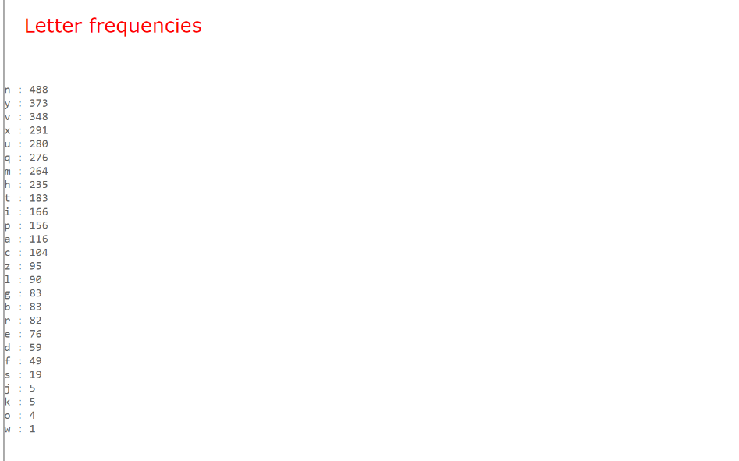

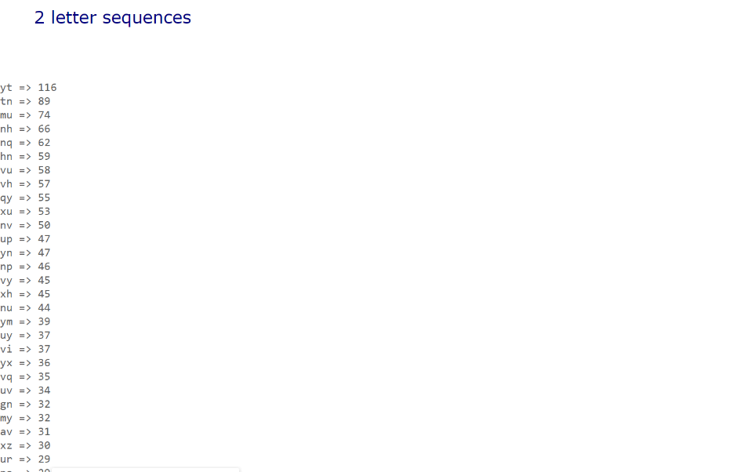

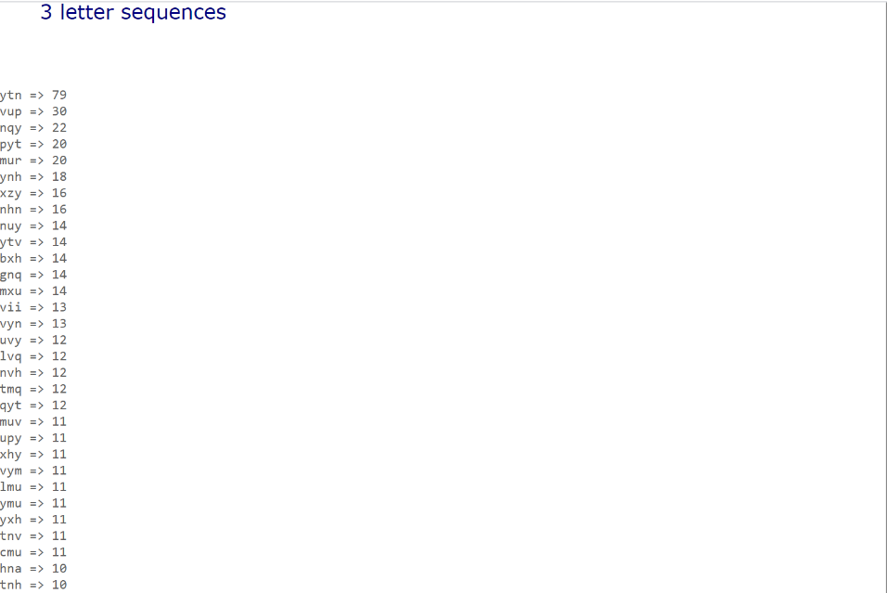

2. Compare the word frequency with and statistics, combine the outcome with those characters which have already been solved, we got the plaintext.

Part of the plaintext:

THE OSCARS TURN ON SUNDAY WHICH SEEMS ABOUT RIGHT AFTER THIS LONG STRANGE

AWARDS TRIP THE BAGGER FEELS LIKE A NONAGENARIAN TOO

THE AWARDS RACE WAS BOOKENDED BY THE DEMISE OF HARVEY WEINSTEIN AT ITS OUTSET

AND THE APPARENT IMPLOSION OF HIS FILM COMPANY AT THE END AND IT WAS SHAPED BY

THE EMERGENCE OF METOO TIMES UP BLACKGOWN POLITICS ARMCANDY ACTIVISM AND

A NATIONAL CONVERSATION AS BRIEF AND MAD AS A FEVER DREAM ABOUT WHETHER THERE

OUGHT TO BE A PRESIDENT WINFREY THE SEASON DIDNT JUST SEEM EXTRA LONG IT WAS

EXTRA LONG BECAUSE THE OSCARS WERE MOVED TO THE FIRST WEEKEND IN MARCH TO

AVOID CONFLICTING WITH THE CLOSING CEREMONY OF THE WINTER OLYMPICS THANKS

PYEONGCHANG … …

Task 2: Encryption using Different Ciphers and Modes

In this task, we will play with various encryption algorithms and modes. You can use the following openssl enc command to encrypt/decrypt a file. To see the manuals, you can type man openssl and man enc. Please replace the ciphertype with a specific cipher type, such as -aes-128-cbc, -bf-cbc,-aes-128-cfb, etc. In this task, you should try at least 3 different ciphers.

Experiment:

We create a txt file which contains the following sentence.

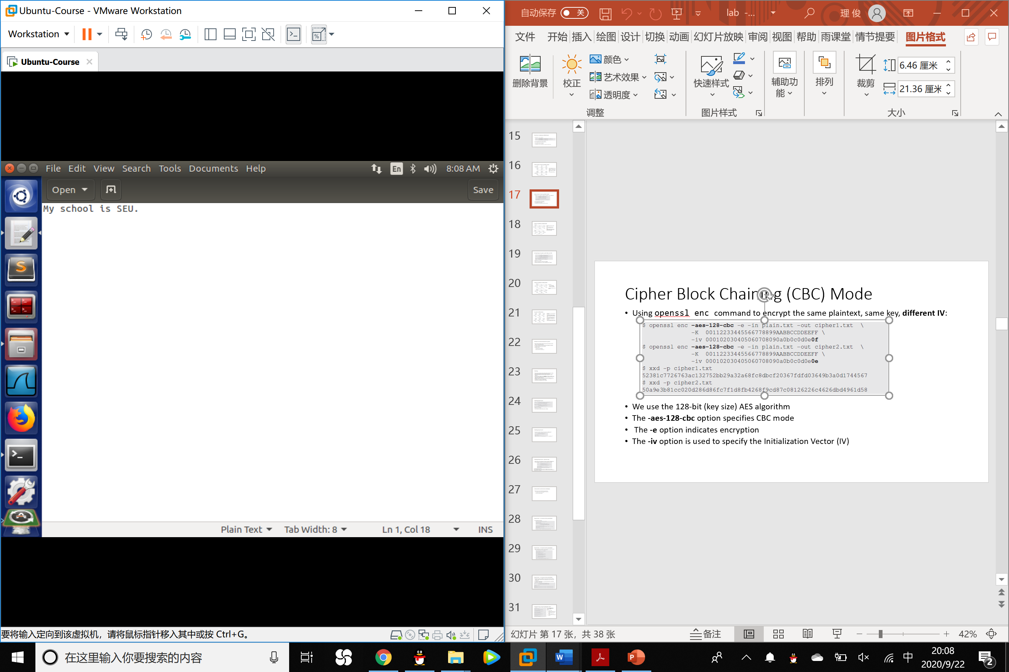

We encrypt the file in the following three modes then check the outcome:

Aes-128-cfb aes-128-cbc bf-cbc

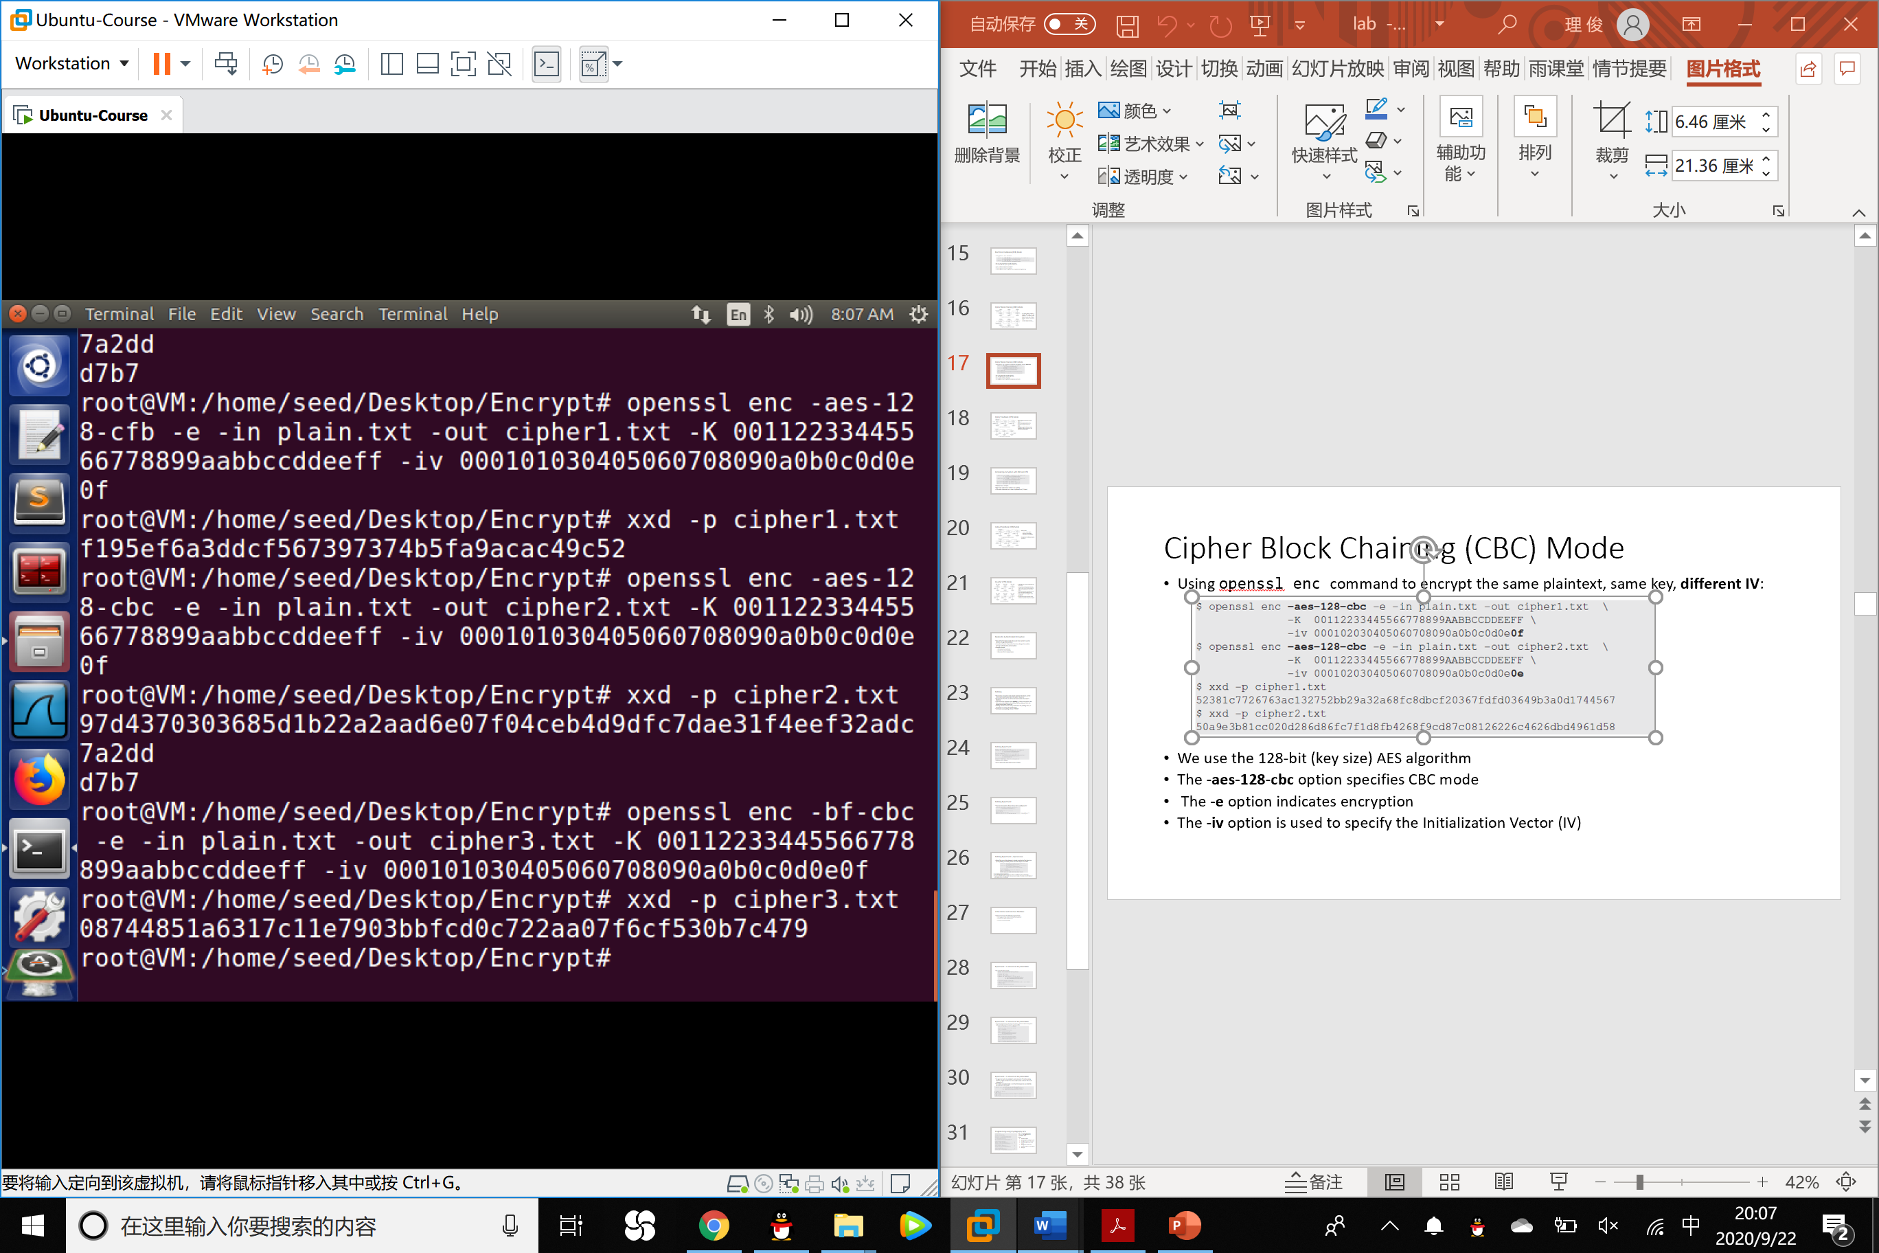

Task 3: Encryption Mode – ECB vs. CBC

The file pic original.bmp can be downloaded from this lab’s website, and it contains a simple picture. We would like to encrypt this picture, so people without the encryption keys cannot know what is in the picture. Please encrypt the file using the ECB (Electronic Code Book) and CBC (Cipher Block Chaining) modes, and then do the following:

1. Let us treat the encrypted picture as a picture, and use a picture viewing software to display it. However, for the .bmp file, the first 54 bytes contain the header information about the picture, we have to set it correctly, so the encrypted file can be treated as a legitimate .bmp file.

Experiment:

ECB mode encryption:

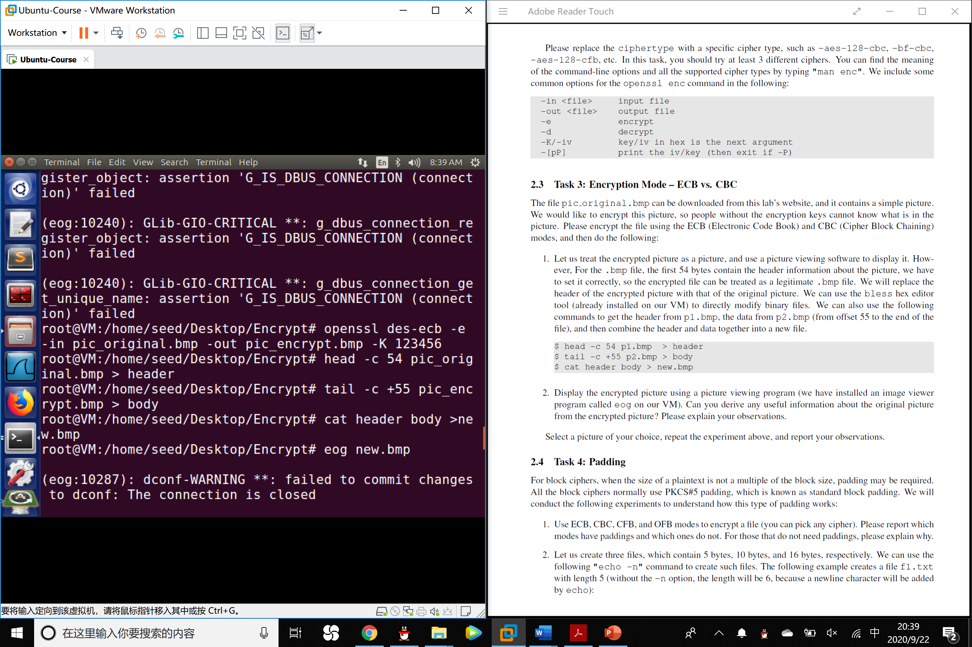

CBC mode encryption:

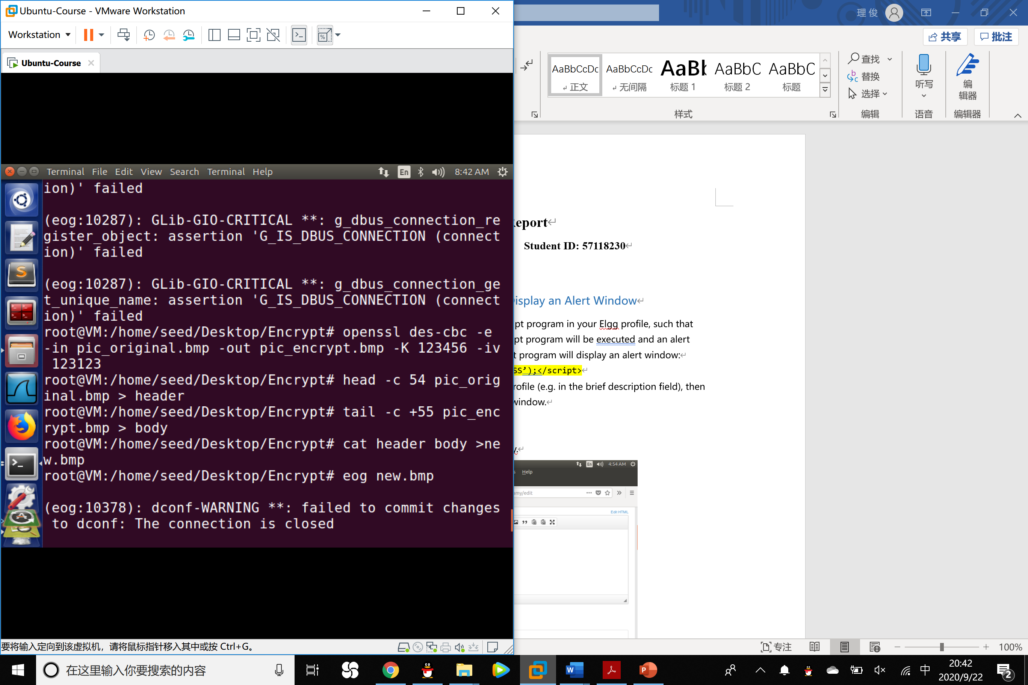

2. Display the encrypted picture using a picture viewing program (we have installed an image viewer program called eog on our VM). Can you derive any useful information about the original picture from the encrypted picture? Please explain your observations.

Experiment:

The original picture:

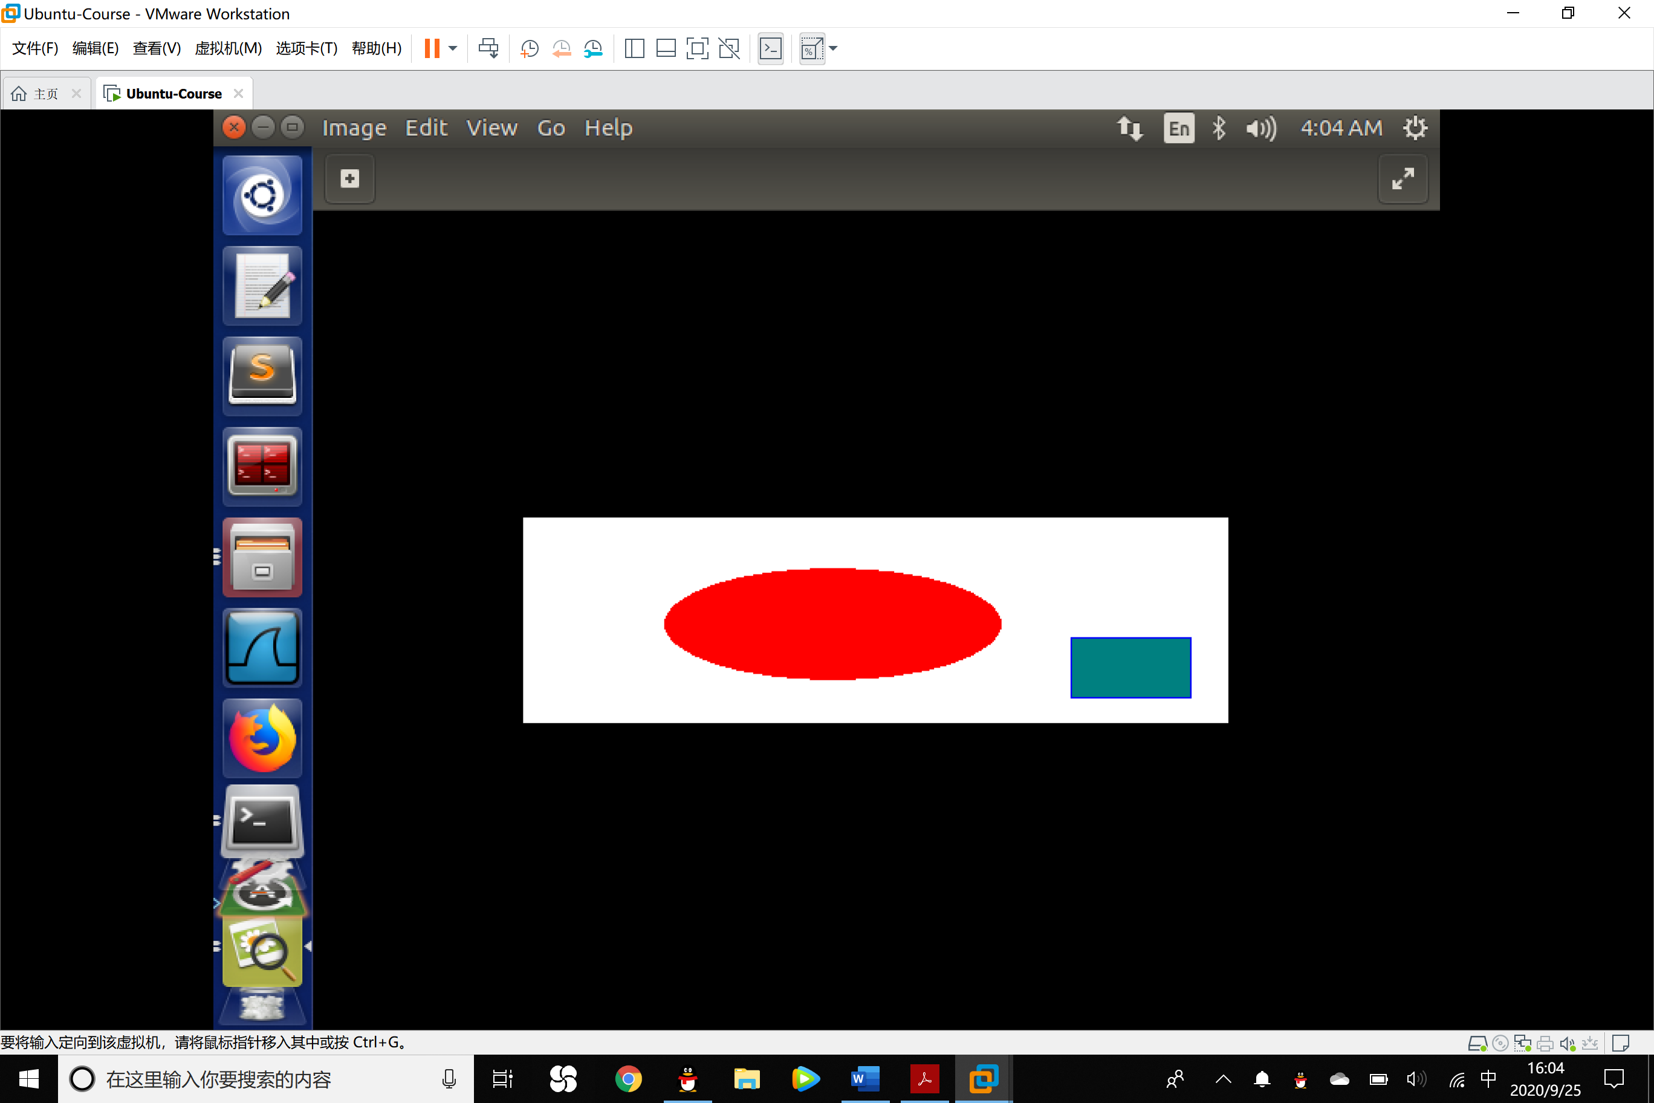

The encrypted picture using the ECB encryption mode:

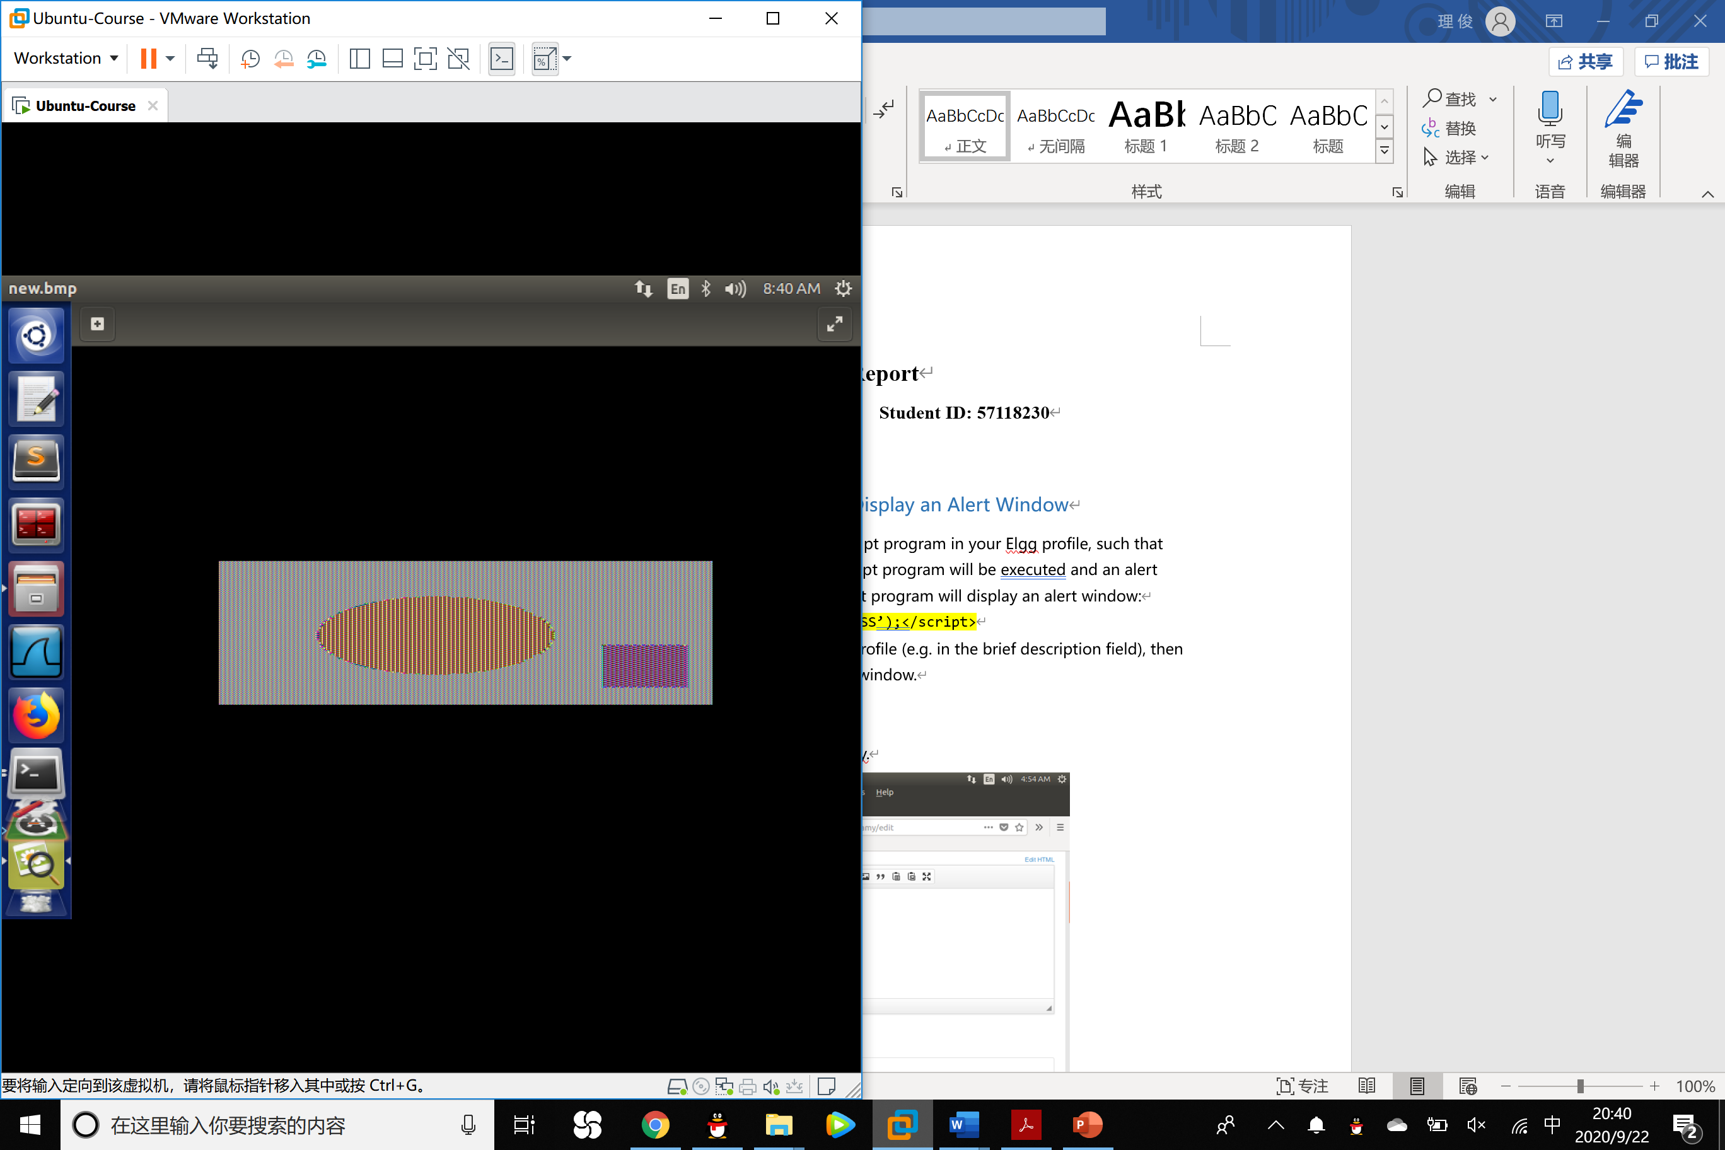

The encrypted picture using the CBC encryption mode:

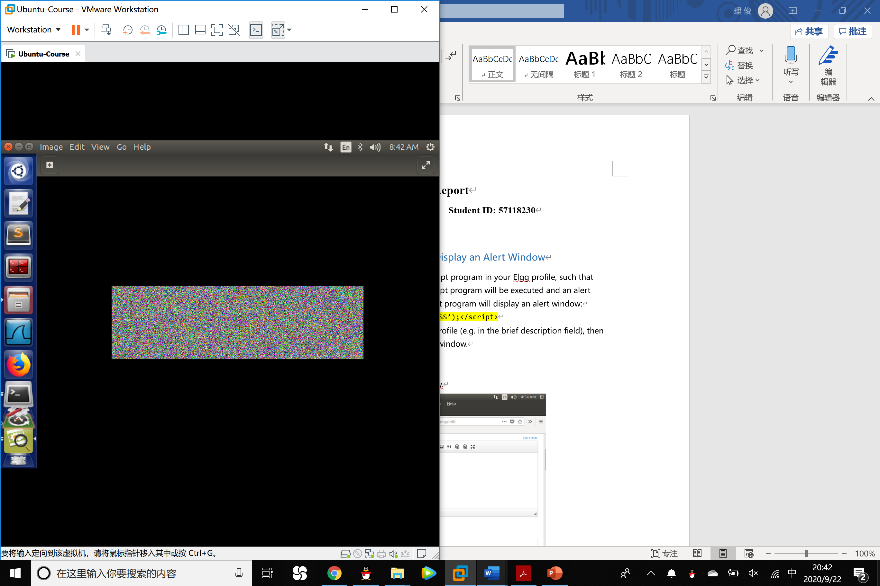

Observation: In the mode of ECB, the difference between the original picture and the encrypted picture is only the color, it can be observed that the pixels with the same color all turns to another same color. We can get the shape and the outline of the picture from the original picture from the encrypted picture. But in the mode of CBC, what we can see in the encrypted picture is only all pixels with color chaos and we can not see the shape or the outline of the original picture from the encrypted one.

3. Select a picture of your choice, repeat the experiment above, and report your observations.

Experiment：

Original picture:

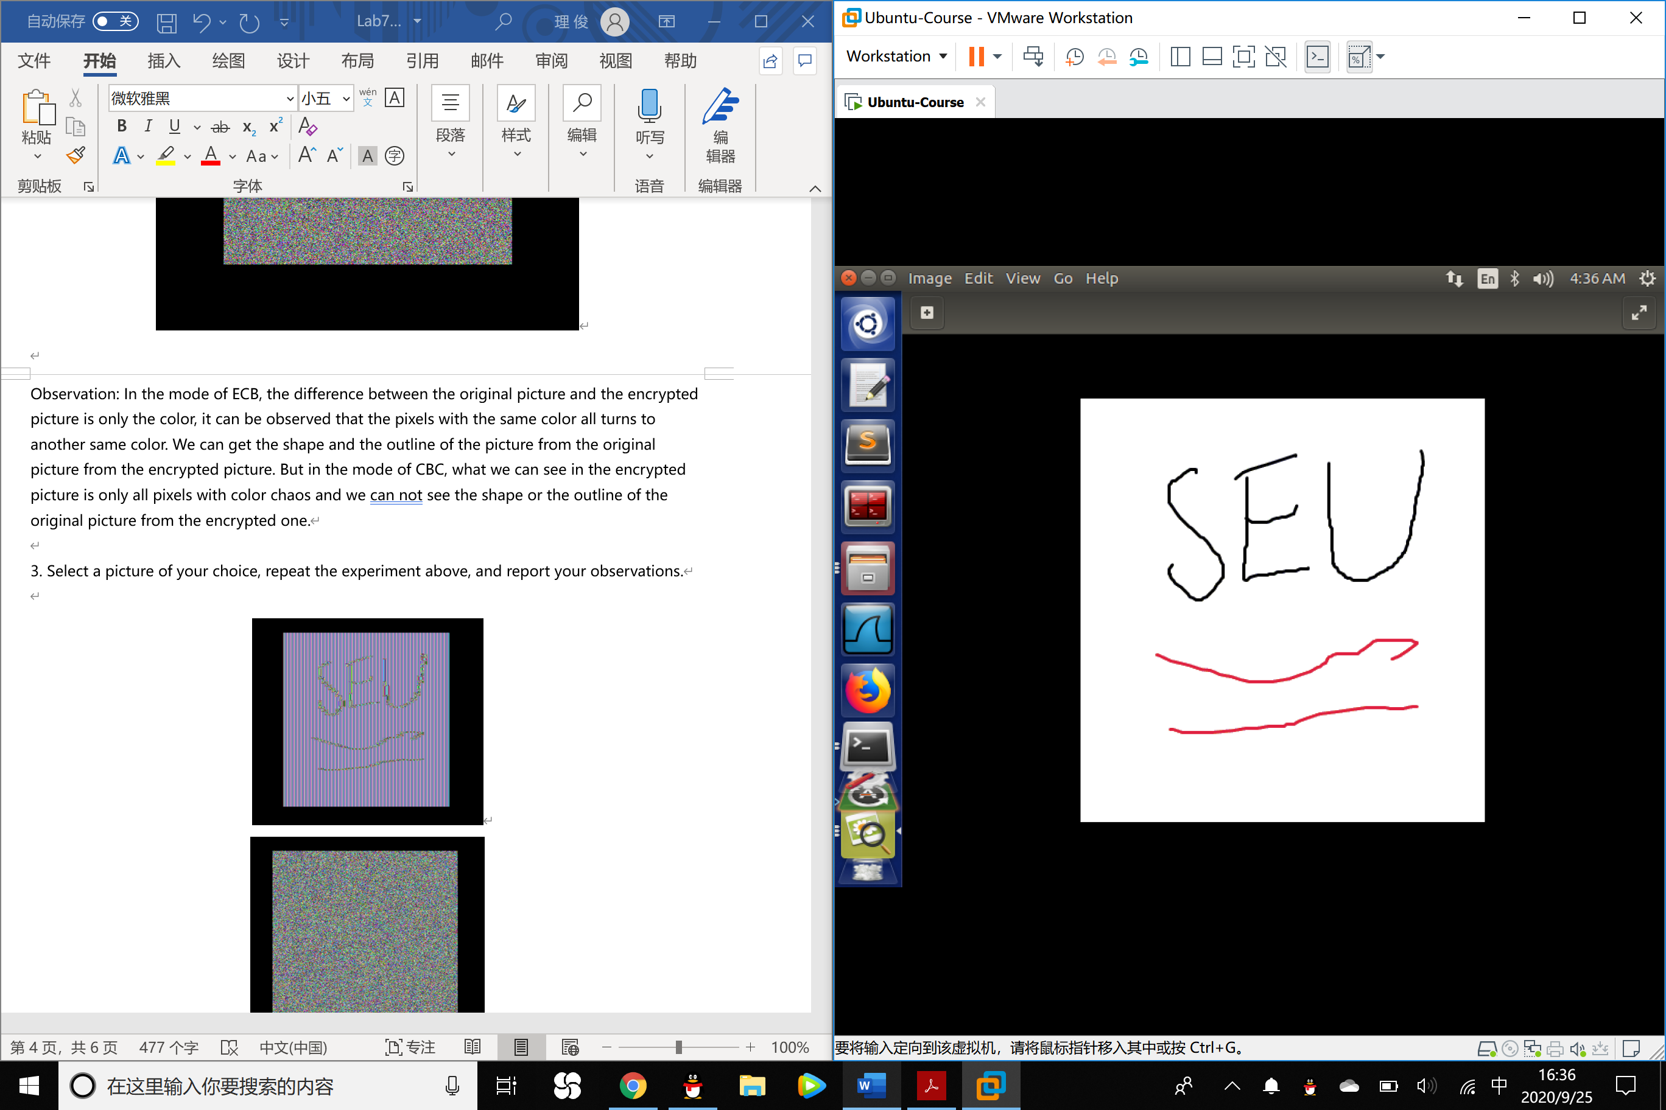

ECB mode encryption picture：

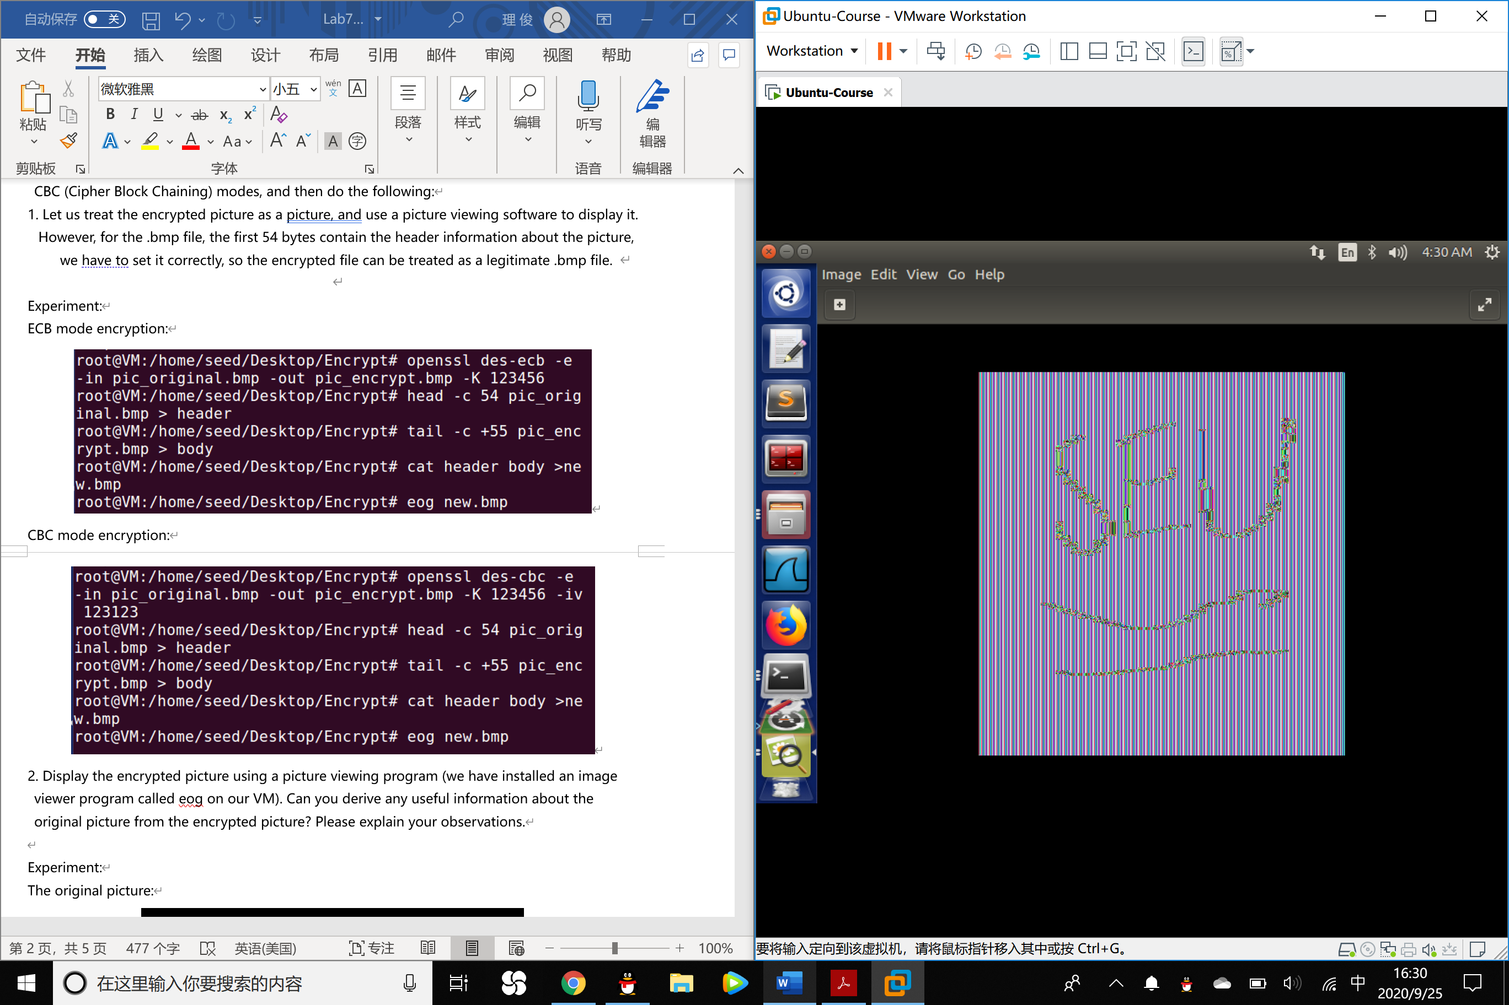

CBC mode encryption picture:

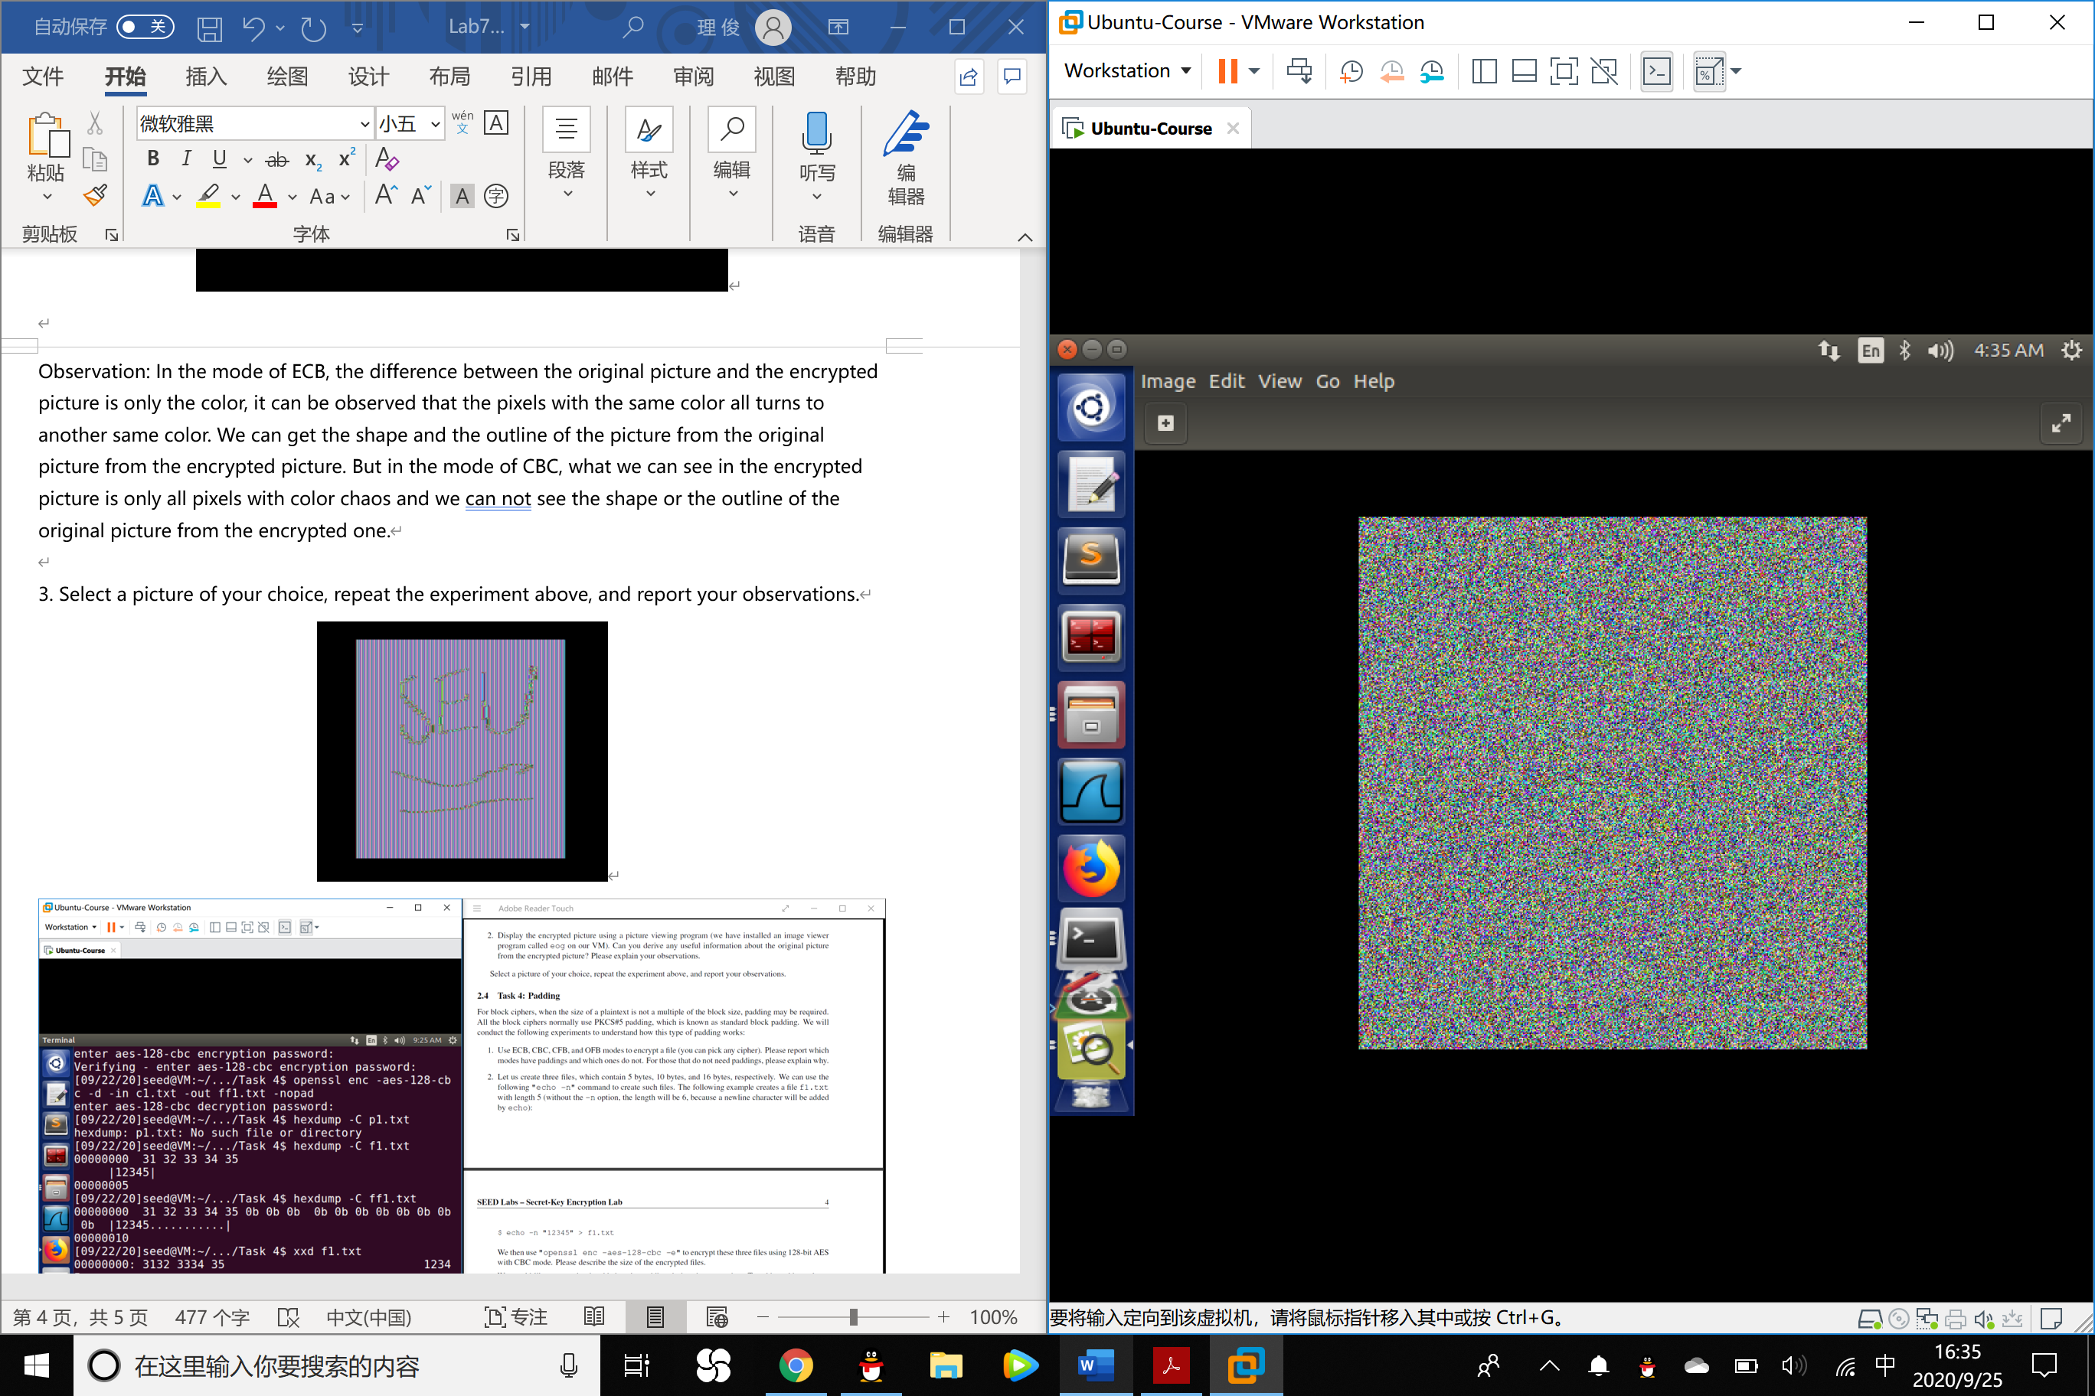

Observation: The outcome is exactly the same as the conclusion we got in the second step.

Task 4: Padding

For block ciphers, when the size of a plaintext is not a multiple of the block size, padding may be required. All the block ciphers normally use PKCS#5 padding, which is known as standard block padding. We will conduct the following experiments to understand how this type of padding works:

1. Use ECB, CBC, CFB, and OFB modes to encrypt a file (you can pick any cipher). Please report which modes have paddings and which ones do not. For those that do not need paddings, please explain why.

Answer: ECB and CBC mode needs padding while CFB and OFB mode do not.

2. Let us create three files, which contain 5 bytes, 10 bytes, and 16 bytes, respectively. We can use the following "echo -n" command to create such files. The following example creates a file f1.txt with length 5 (without the -n option, the length will be 6, because a newline character will be added by echo):

$ echo -n "12345" > f1.txt

We then use "openssl enc -aes-128-cbc -e" to encrypt these three files using 128-bit AES with CBC mode. Please describe the size of the encrypted files.

Answer:

|  |  |  |
| --- | --- | --- |
| Number\Property | Plaintext size (Bytes) | Ciphertext size (Bytes) |
| 1 | 5 | 16 |
| 2 | 10 | 16 |
| 3 | 16 | 32 |

3. By looking at the decrypted data, we can see what data are used in the padding. Please use this technique to figure out what paddings are added to the three files.

Observations：

5 bytes file:

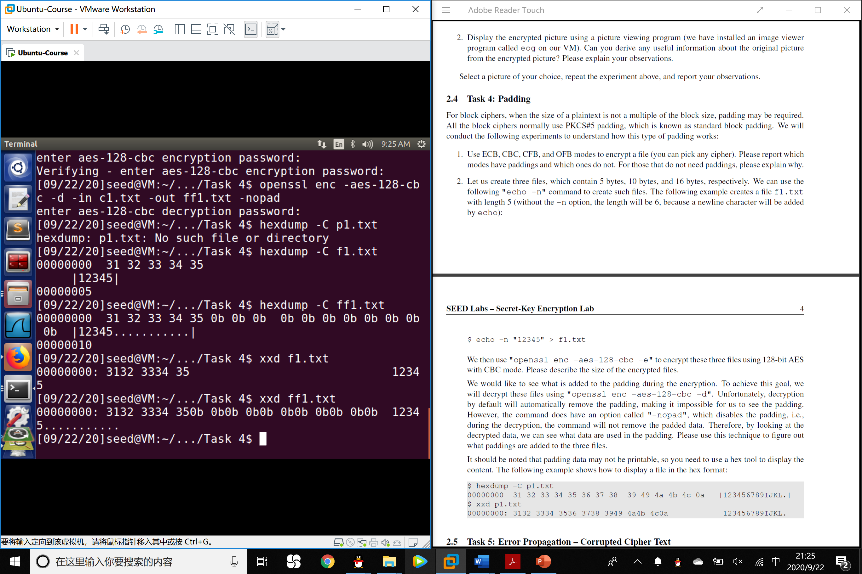

10 bytes file:

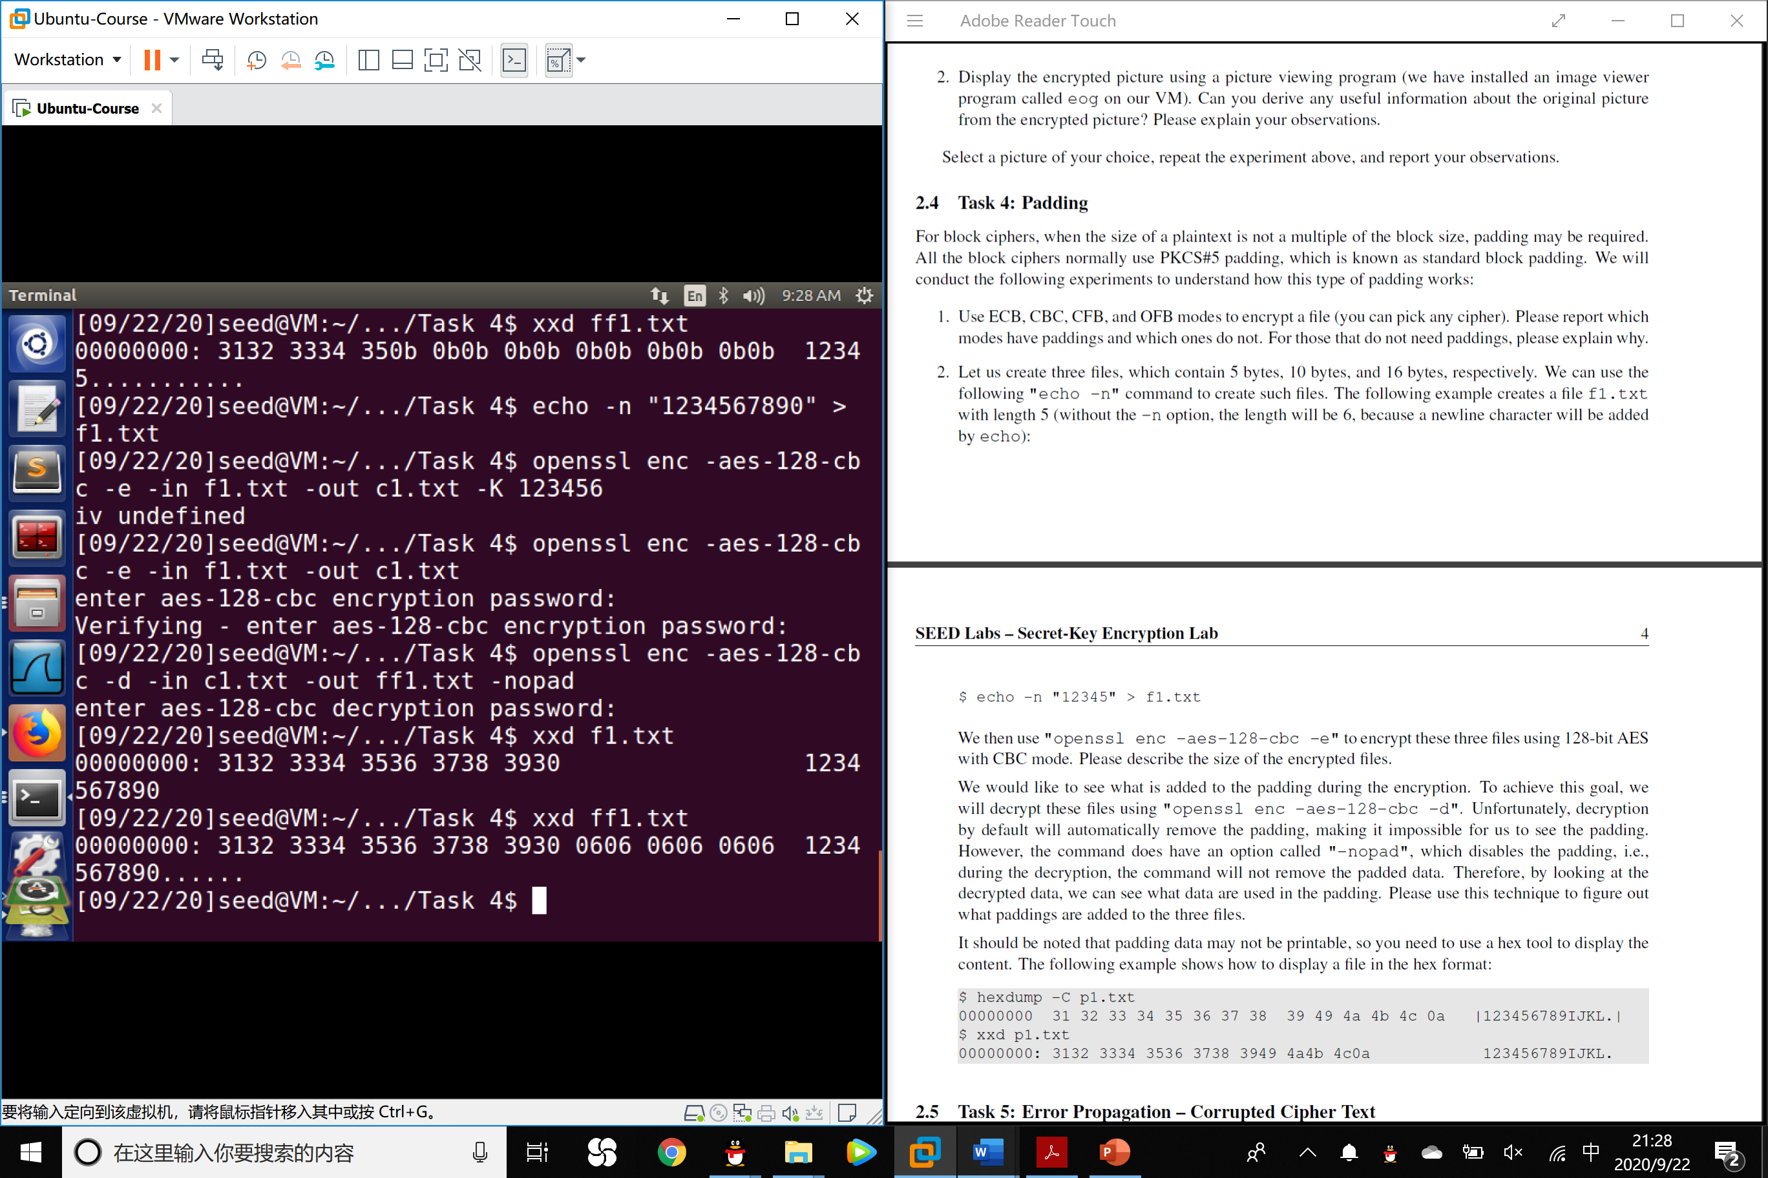

16 bytes file:

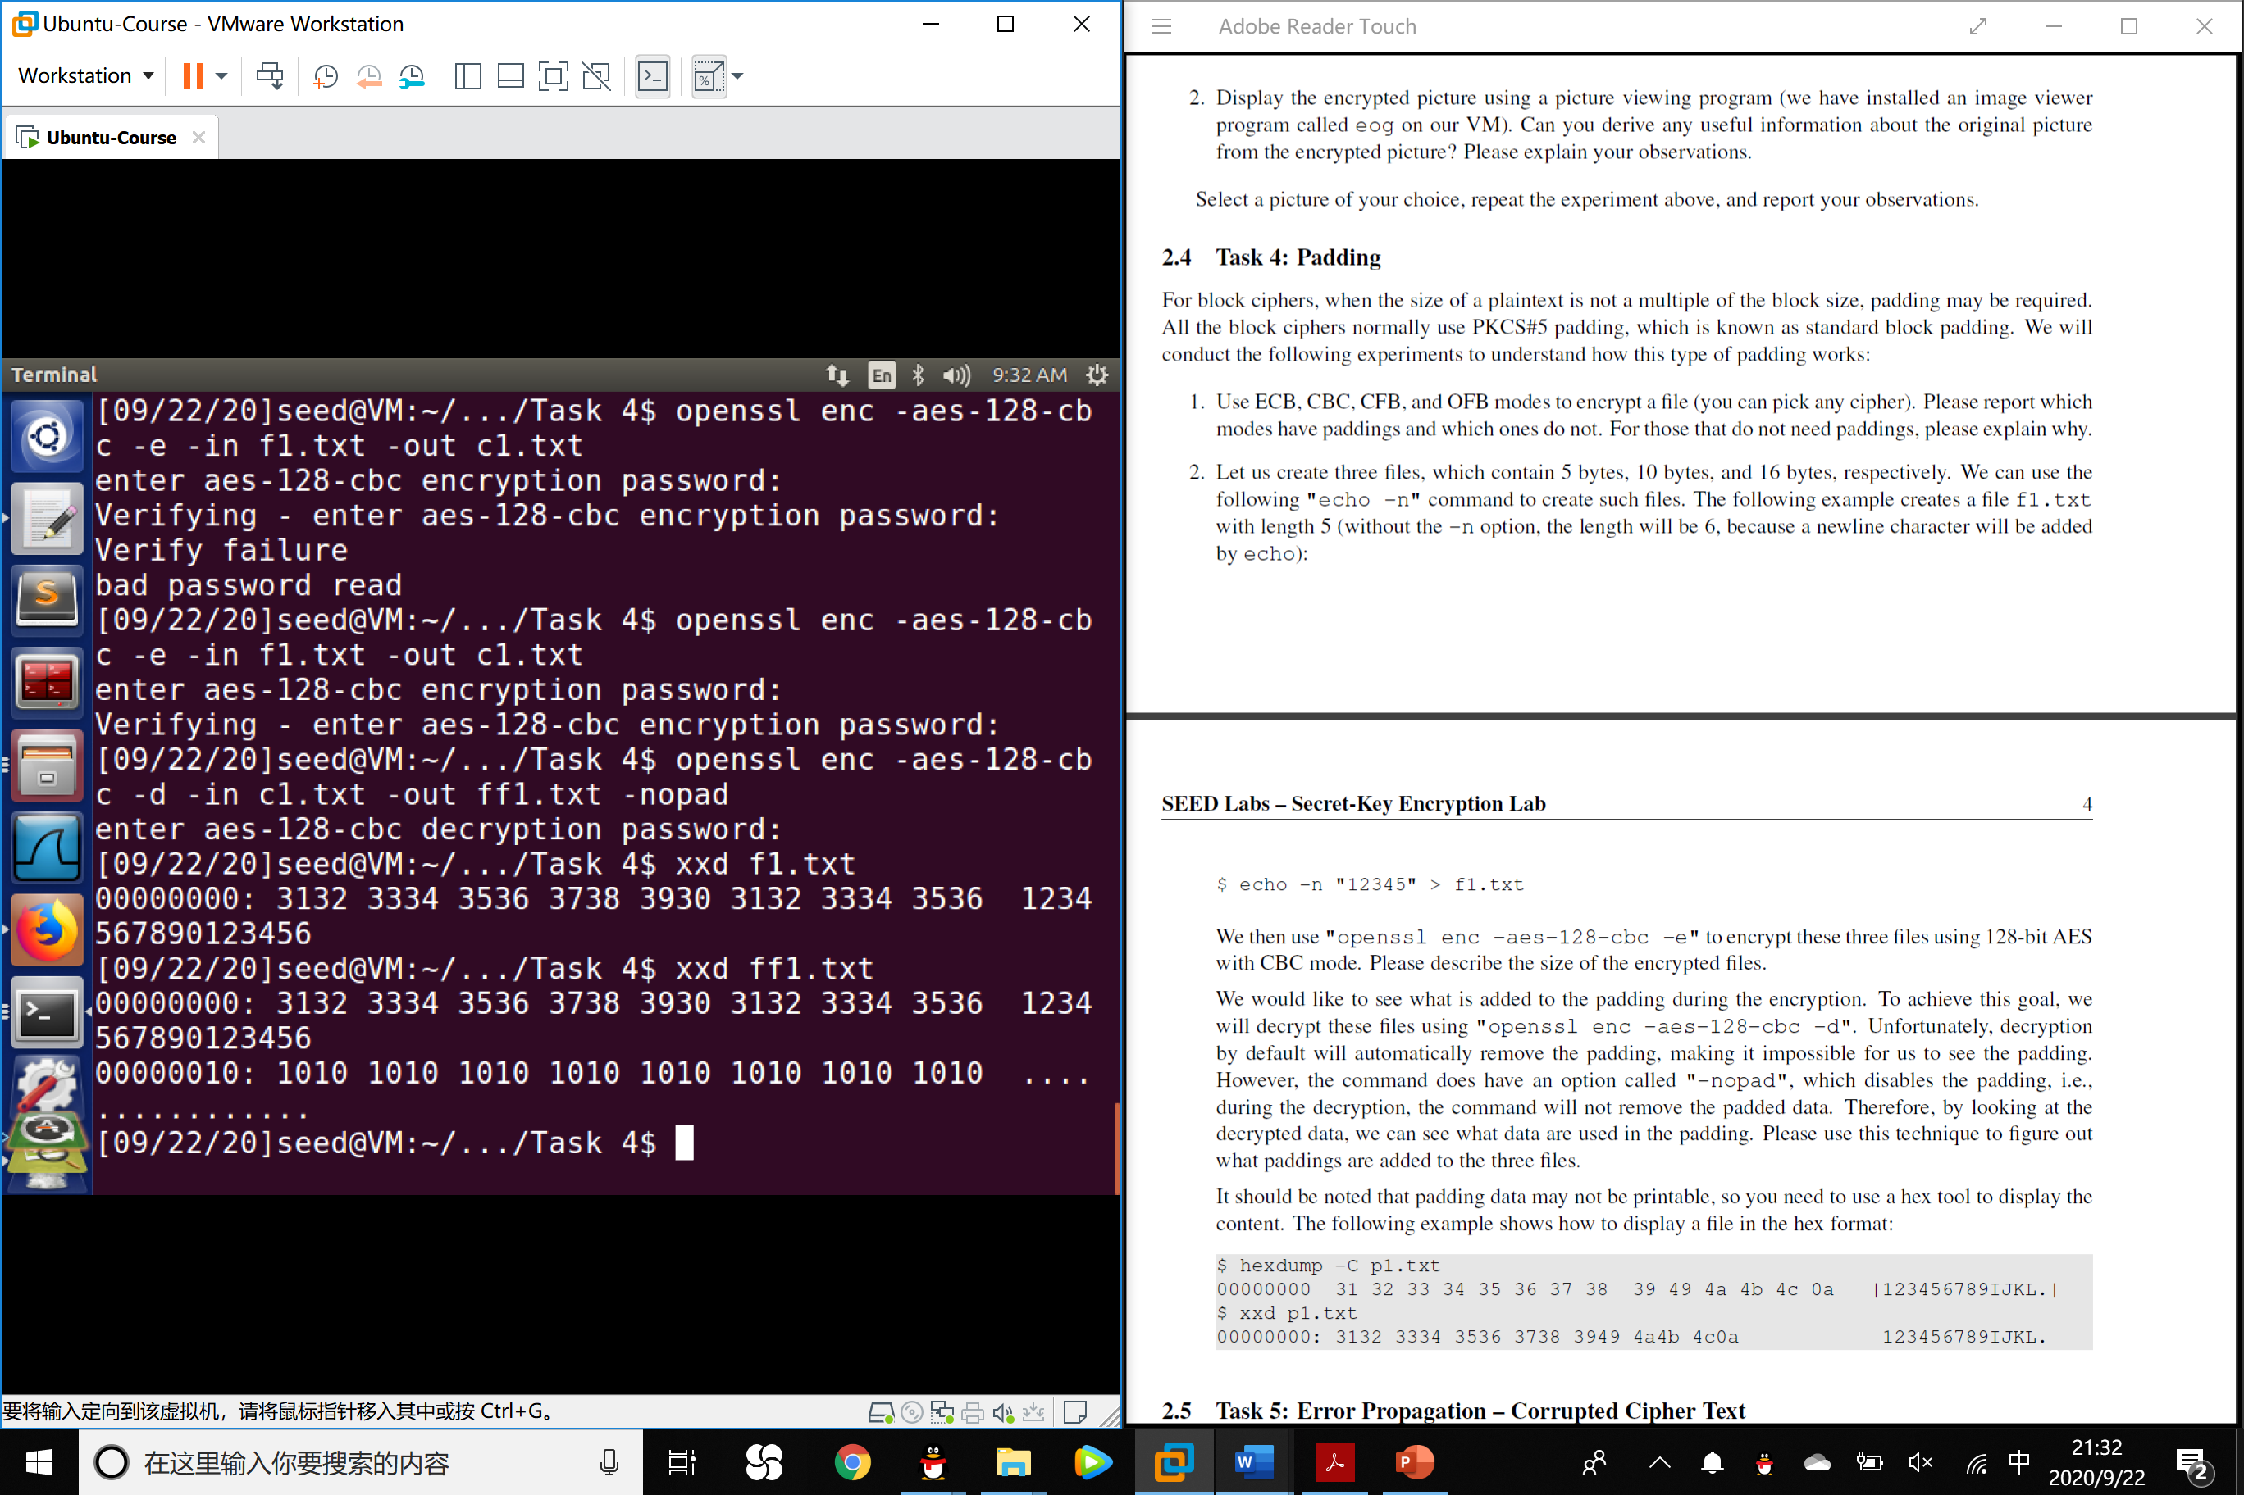

Task 5: Error Propagation – Corrupted Cipher Text

To understand the error propagation property of various encryption modes, we would like to do the following exercise:

1. Create a text file that is at least 1000 bytes long.

2. Encrypt the file using the AES-128 cipher.

3. Unfortunately, a single bit of the 55th byte in the encrypted file got corrupted. You can achieve this

corruption using the bless hex editor.

4. Decrypt the corrupted ciphertext file using the correct key and IV.

Please answer the following question: How much information can you recover by decrypting the corrupted file, if the encryption mode is ECB, CBC, CFB, or OFB, respectively? Please answer this question before you conduct this task, and then find out whether your answer is correct or wrong after you finish this task. Please provide justification.

Answer:

In ECB mode, a wrong byte in the cypher text could only affect the decrypted outcome of that single group.

In CBC mode, a wrong byte in the cypher test will affect all the groups in the decryption.

In CFB mode, a wrong byte in the cypher test will affect the decryption outcome of that group and the following n/r groups, where n is the length of a single group and r is the remove bit of the LFSR.

In OFB mode, a wrong byte in the cypher text only affect that particular character in decryption.

Justification:

Plaintext:

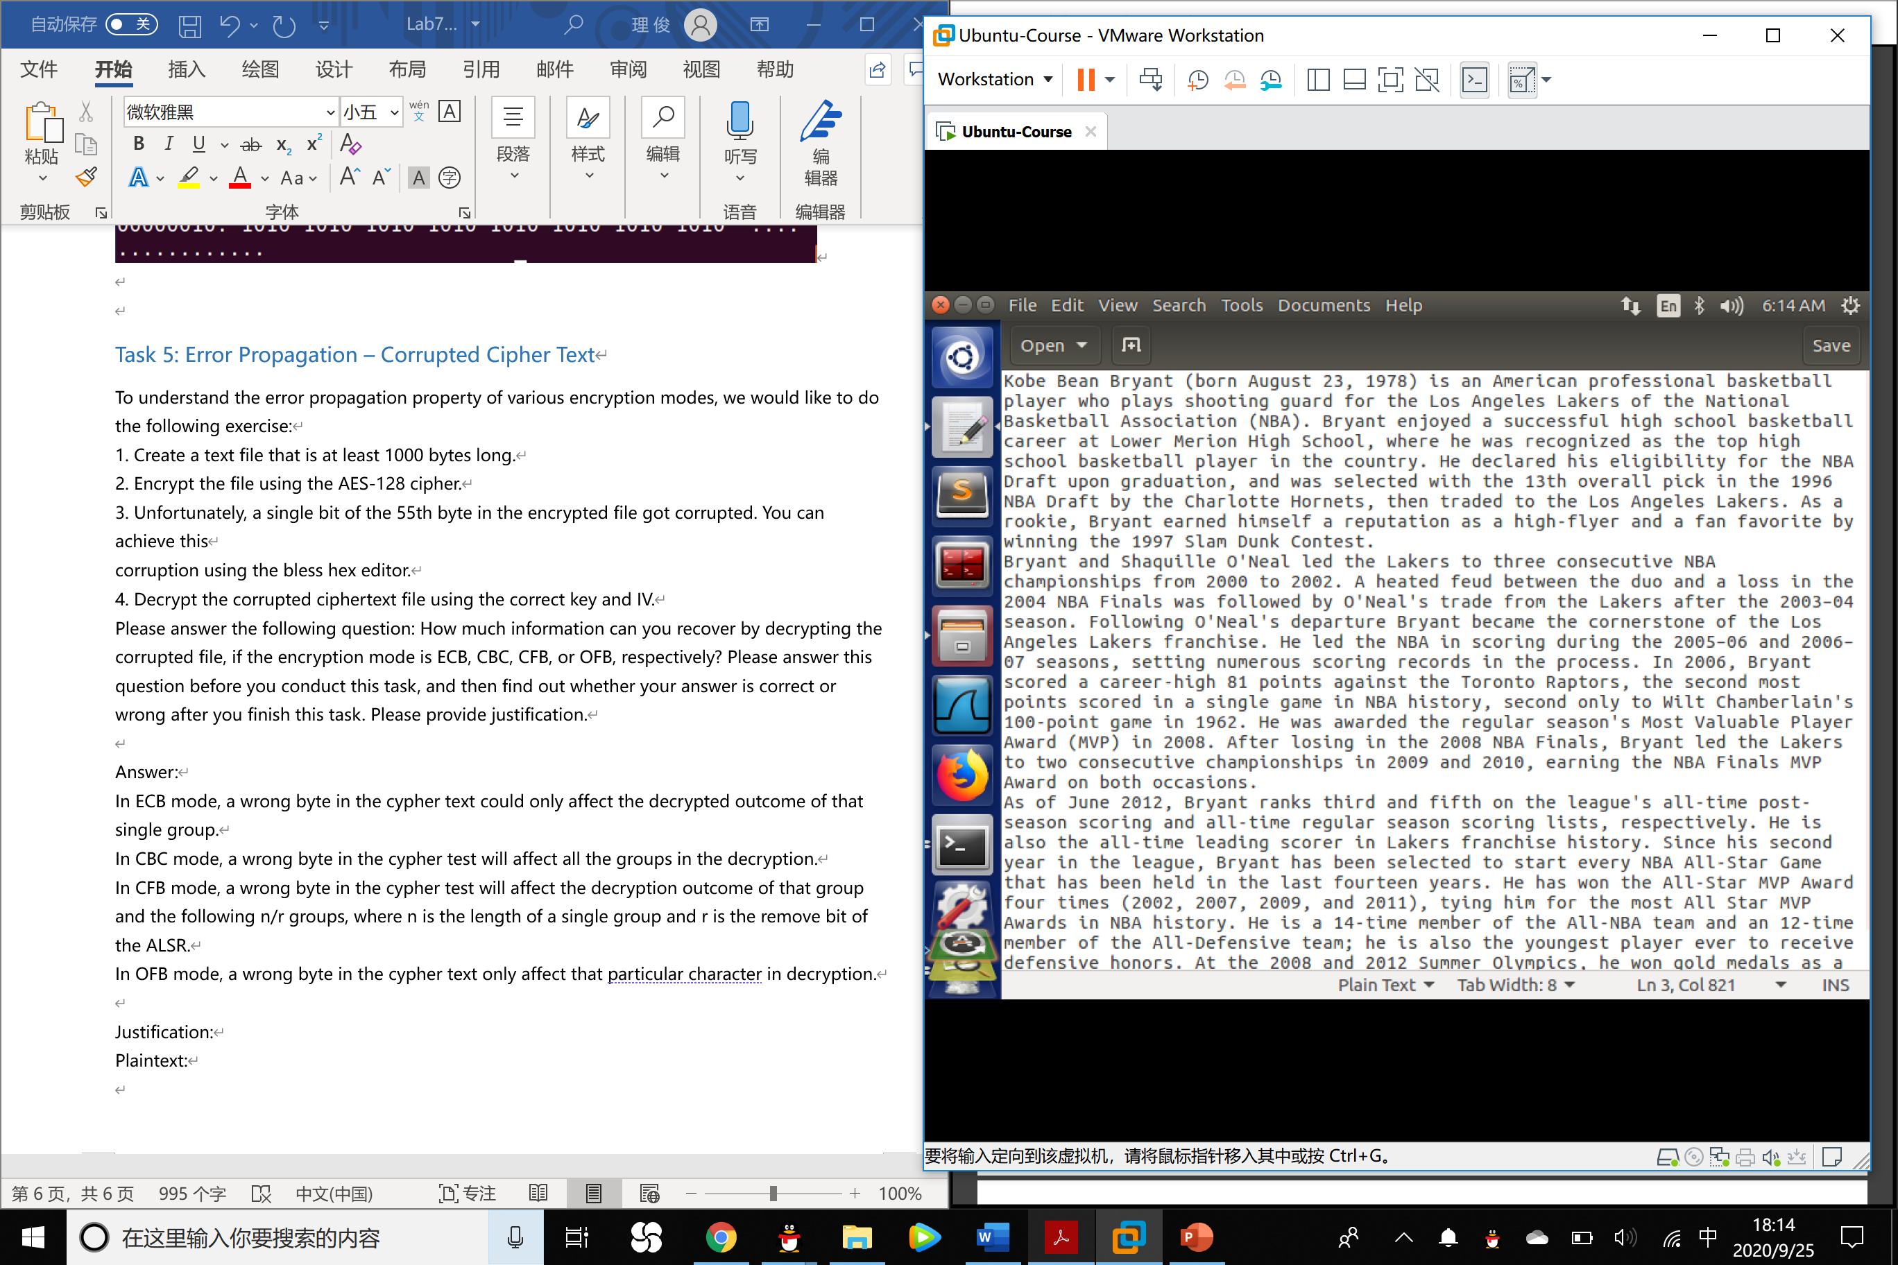

ECB decryption:

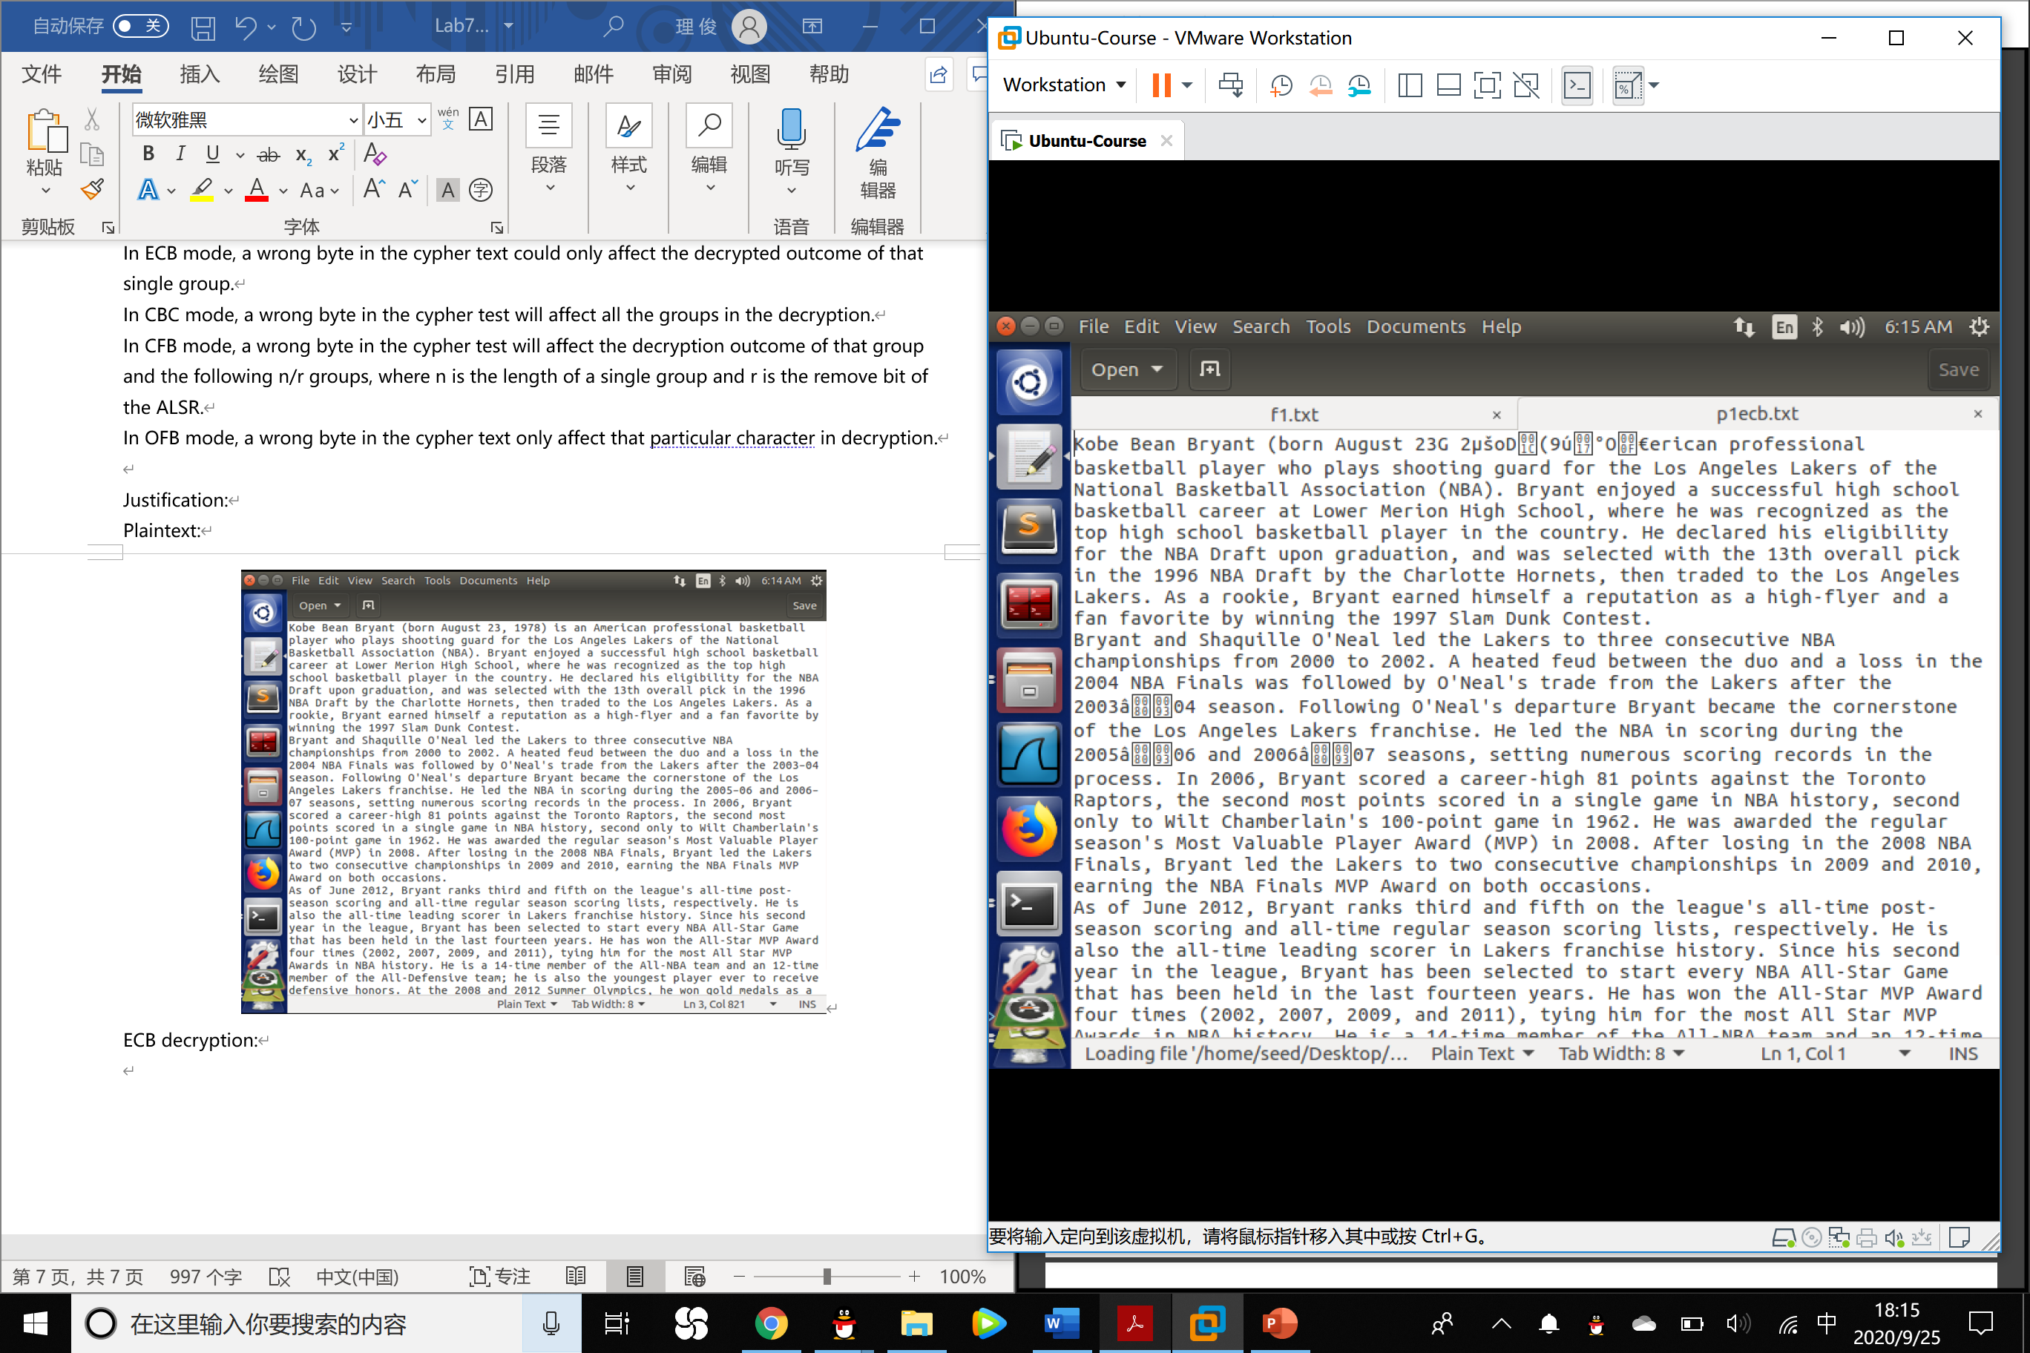

CBC decryption:

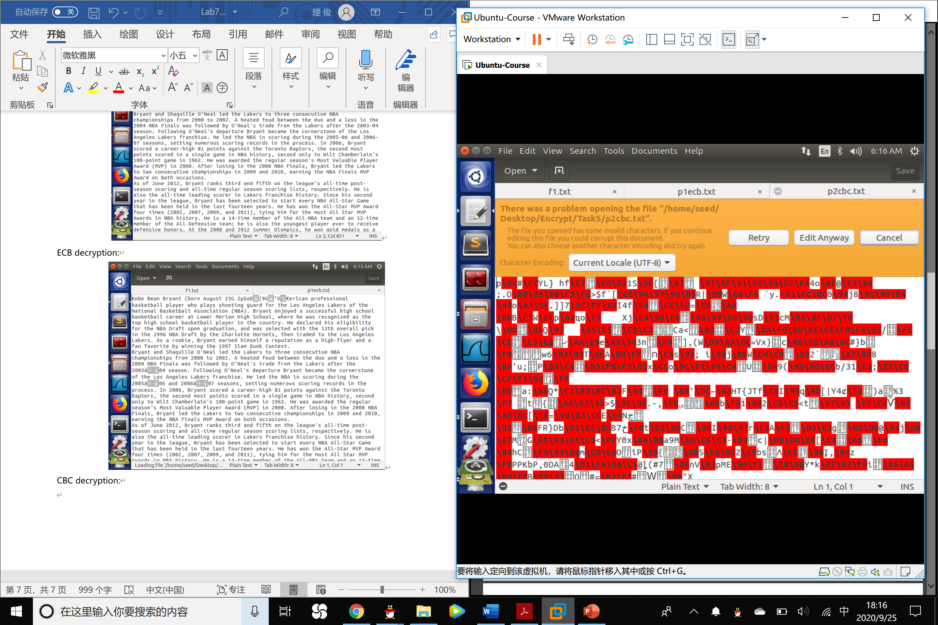

CFB decryption:

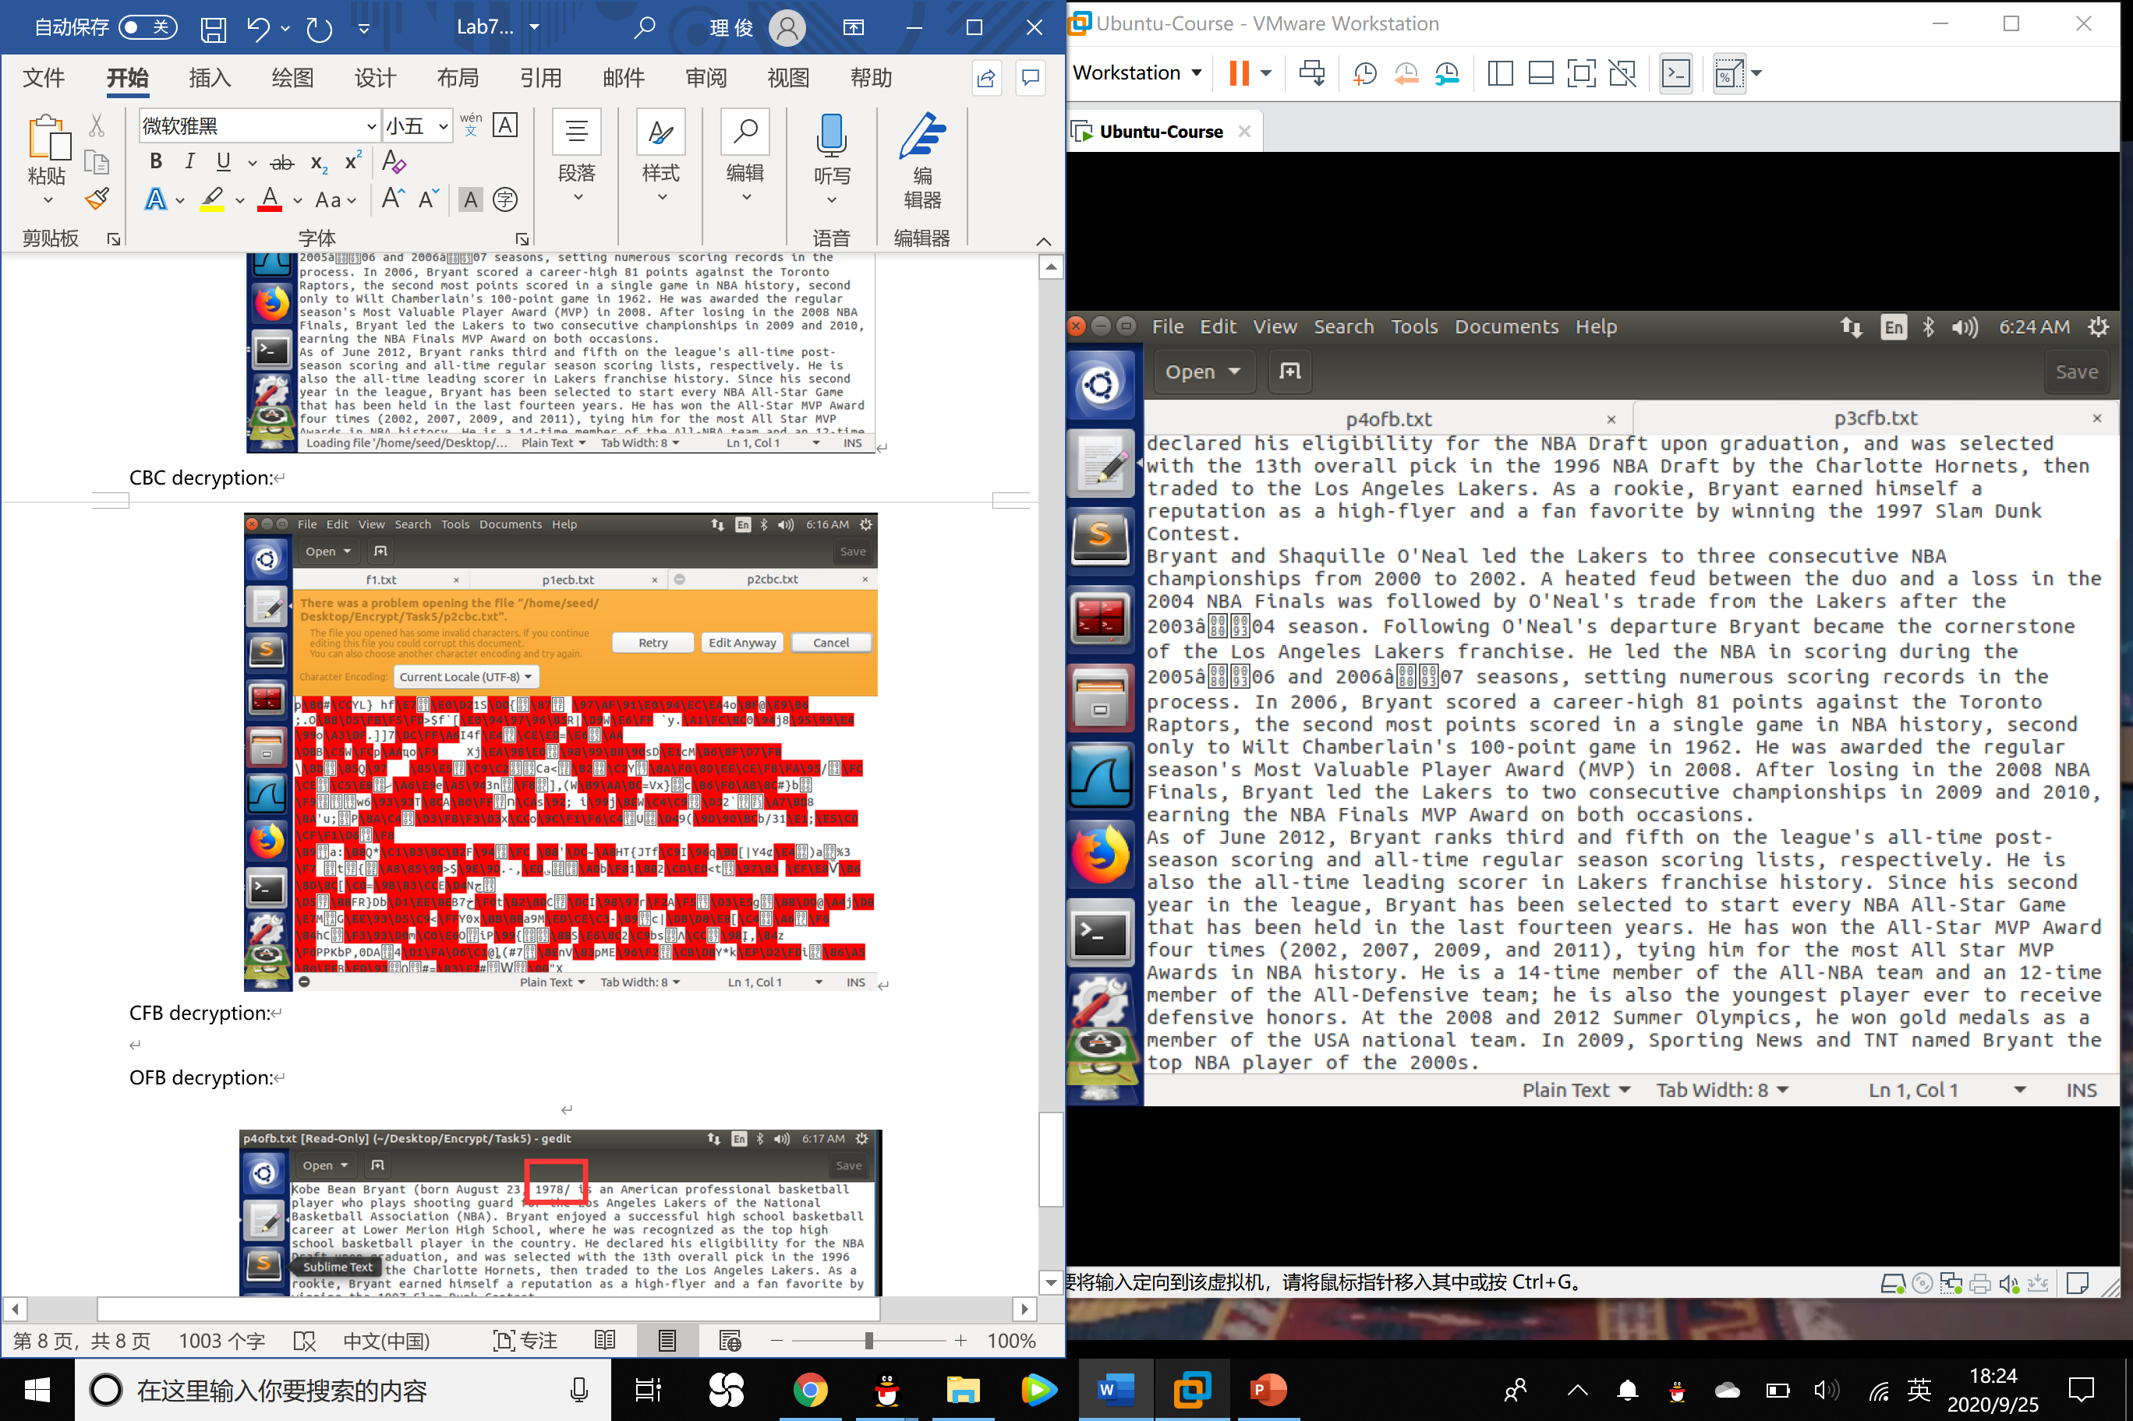

OFB decryption:

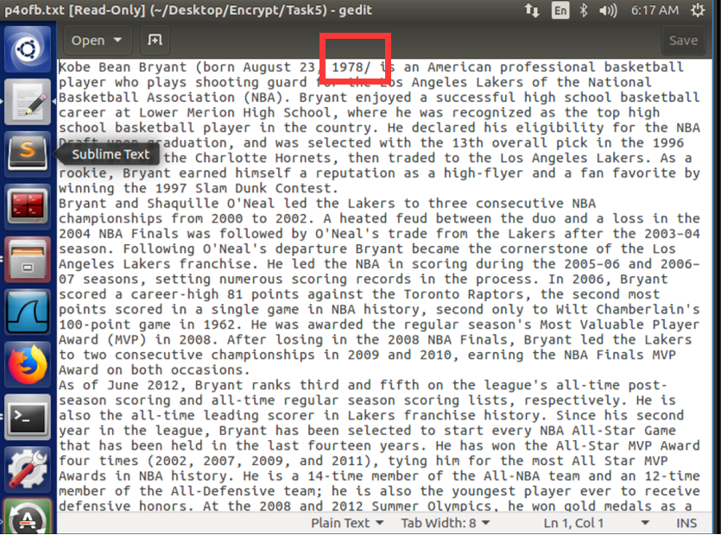

Task 6: Initial Vector (IV)

Most of the encryption modes require an initial vector (IV). Properties of an IV depend on the cryptographic scheme used. If we are not careful in selecting IVs, the data encrypted by us may not be secure at all, even though we are using a secure encryption algorithm and mode. The objective of this task is to help students understand the problems if an IV is not selected properly. Please do the following experiments:

1. A basic requirement for IV is uniqueness, which means that no IV may be reused under the

same key. To understand why, please encrypt the same plaintext using (1) two different IVs, and (2) the same IV. Please describe your observation, based on which, explain why IV needs to be unique.

Observation: Using the same IV, the ciphertexts are the same. So if we transport the message we have already transported before using the same key and IV, the attacker my know that the message is the same as before.

2. One may argue that if the plaintext does not repeat, using the same IV is safe. Let us look

at the Output Feedback (OFB) mode. Assume that the attacker gets hold of a plaintext (P1) and a ciphertext (C1) , can he/she decrypt other encrypted messages if the IV is always the same? You are given the following information, please try to figure out the actual content of P2 based on C2, P1, and C1.

Plaintext (P1): This is a known message!

Ciphertext (C1): a469b1c502c1cab966965e50425438e1bb1b5f9037a4c159

Plaintext (P2): (unknown to you)

Ciphertext (C2): bf73bcd3509299d566c35b5d450337e1bb175f903fafc159

Experiment:

1.In the OFB mode:

P1 xor IV xor Key=C1 P2 xor IV xor Key =C2

Since IV1=IV2 and Key1=Key2, so that P1 xor C1=P2 xor C2,

So **P2= P1 xor C1 xor C2**

2. Write the program which can execute the xor calculation:

1. #include <stdio.h>
2. #include <string.h>
3. #include <math.h>
5. //ASCII码中将字符转换成对应的十进制数
6. **int** char2int(**char** input)
7. {
8. **return** input > 64 ? (input - 55) : (input - 48);
9. }
11. //ASCII码中将十进制数转换成对应的字符
12. **int** int2char(**char** input)
13. {
14. **return** input > 9 ? (input + 55) : (input + 48);
15. }
17. //将十六进制字符串HexStr1和HexStr2异或得到HexStr
18. **void** hexstrxor(**char** * HexStr1, **char** * HexStr2, **char** * HexStr)
19. {
20. **int** i, iHexStr1Len, iHexStr2Len, iHexStrLenLow, iHexStrLenGap;
22. //转换成大写并求长度, strupr是非标准的C函数，在Linux下不支持，所以需要自己实现或者使用glib中的g_string_ascii_up ()
23. strupr(HexStr1);
24. strupr(HexStr2);
25. iHexStr1Len = strlen(HexStr1);
26. iHexStr2Len = strlen(HexStr2);
28. //获取最小的长度
29. iHexStrLenLow = iHexStr1Len < iHexStr2Len ? iHexStr1Len : iHexStr2Len;
31. //获取长度差值
32. iHexStrLenGap = abs(iHexStr1Len - iHexStr2Len);
34. //两个十六进制的字符串进行异或
35. **for** (i = 0; i < iHexStrLenLow; i++)
36. {
37. *(HexStr + i) = char2int(HexStr1[i]) ^ char2int(HexStr2[i]);
38. *(HexStr + i) = int2char(*(HexStr + i));
39. }
40. **if** (iHexStr1Len > iHexStr2Len)
41. memcpy(HexStr + i, HexStr1 + i, iHexStrLenGap);
42. **else** **if** (iHexStr1Len < iHexStr2Len)
43. memcpy(HexStr + i, HexStr2 + i, iHexStrLenGap);
44. *(HexStr + iHexStrLenLow + iHexStrLenGap) = 0x00;
45. }

48. **int** main(**int** argc, **char** * argv[])
49. {
50. //两个十六进制的字符串以及异或的结果result
51. **char** HexStr1[] = "a469b1c502c1cab966965e50425438e1bb1b5f9037a4c159";
52. **char** HexStr2[] = "bf73bcd3509299d566c35b5d450337e1bb175f903fafc159";
53. **char** s3[] = "546869732069732061206b6e6f776e206d65737361676521";
54. **char** result[49] = { 0 };
55. **char** result1[49] = { 0 };
57. //调用异或方法
58. hexstrxor(HexStr1, HexStr2, result);
59. hexstrxor(result, s3, result1);
60. //打印异或结果
61. printf("\nresult=[%s]\n", result1);
63. **return** 0;
64. };

In line 51,52,53, we input the hex string of P1 and the C1,C2.

Do not forget to delete the 0a character in the P1, which works for changing the line.

3. Transport the output to file:

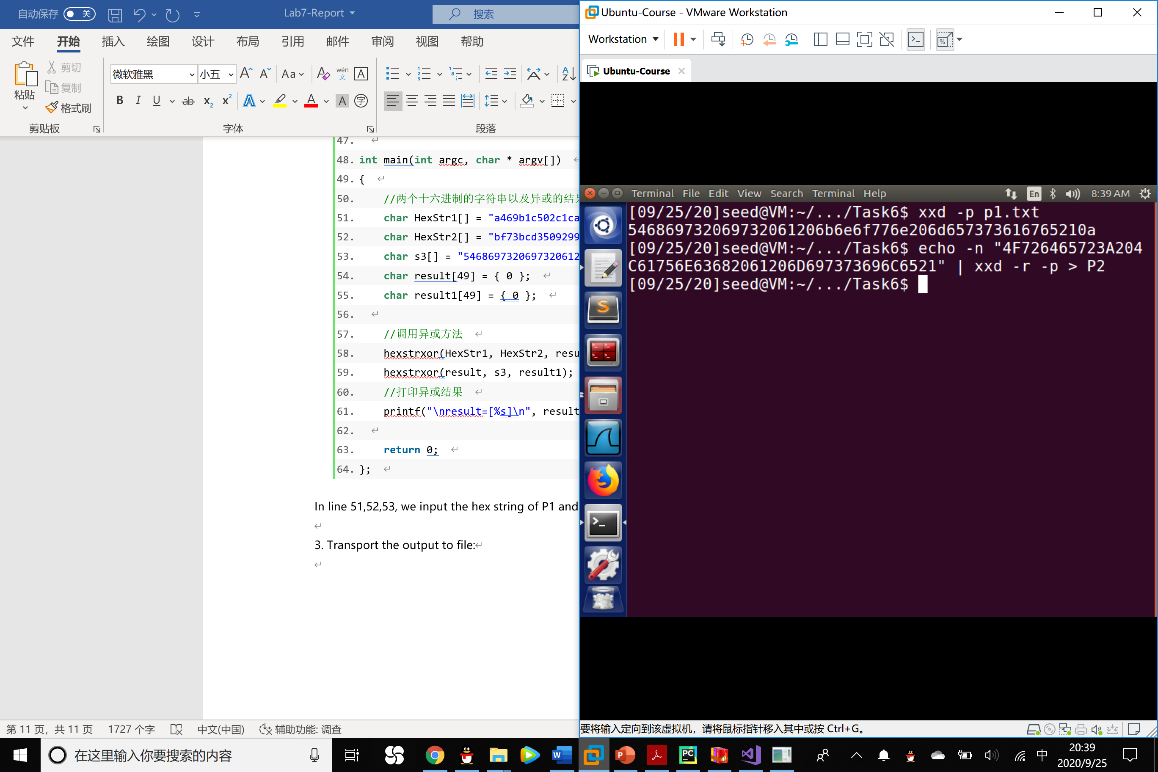

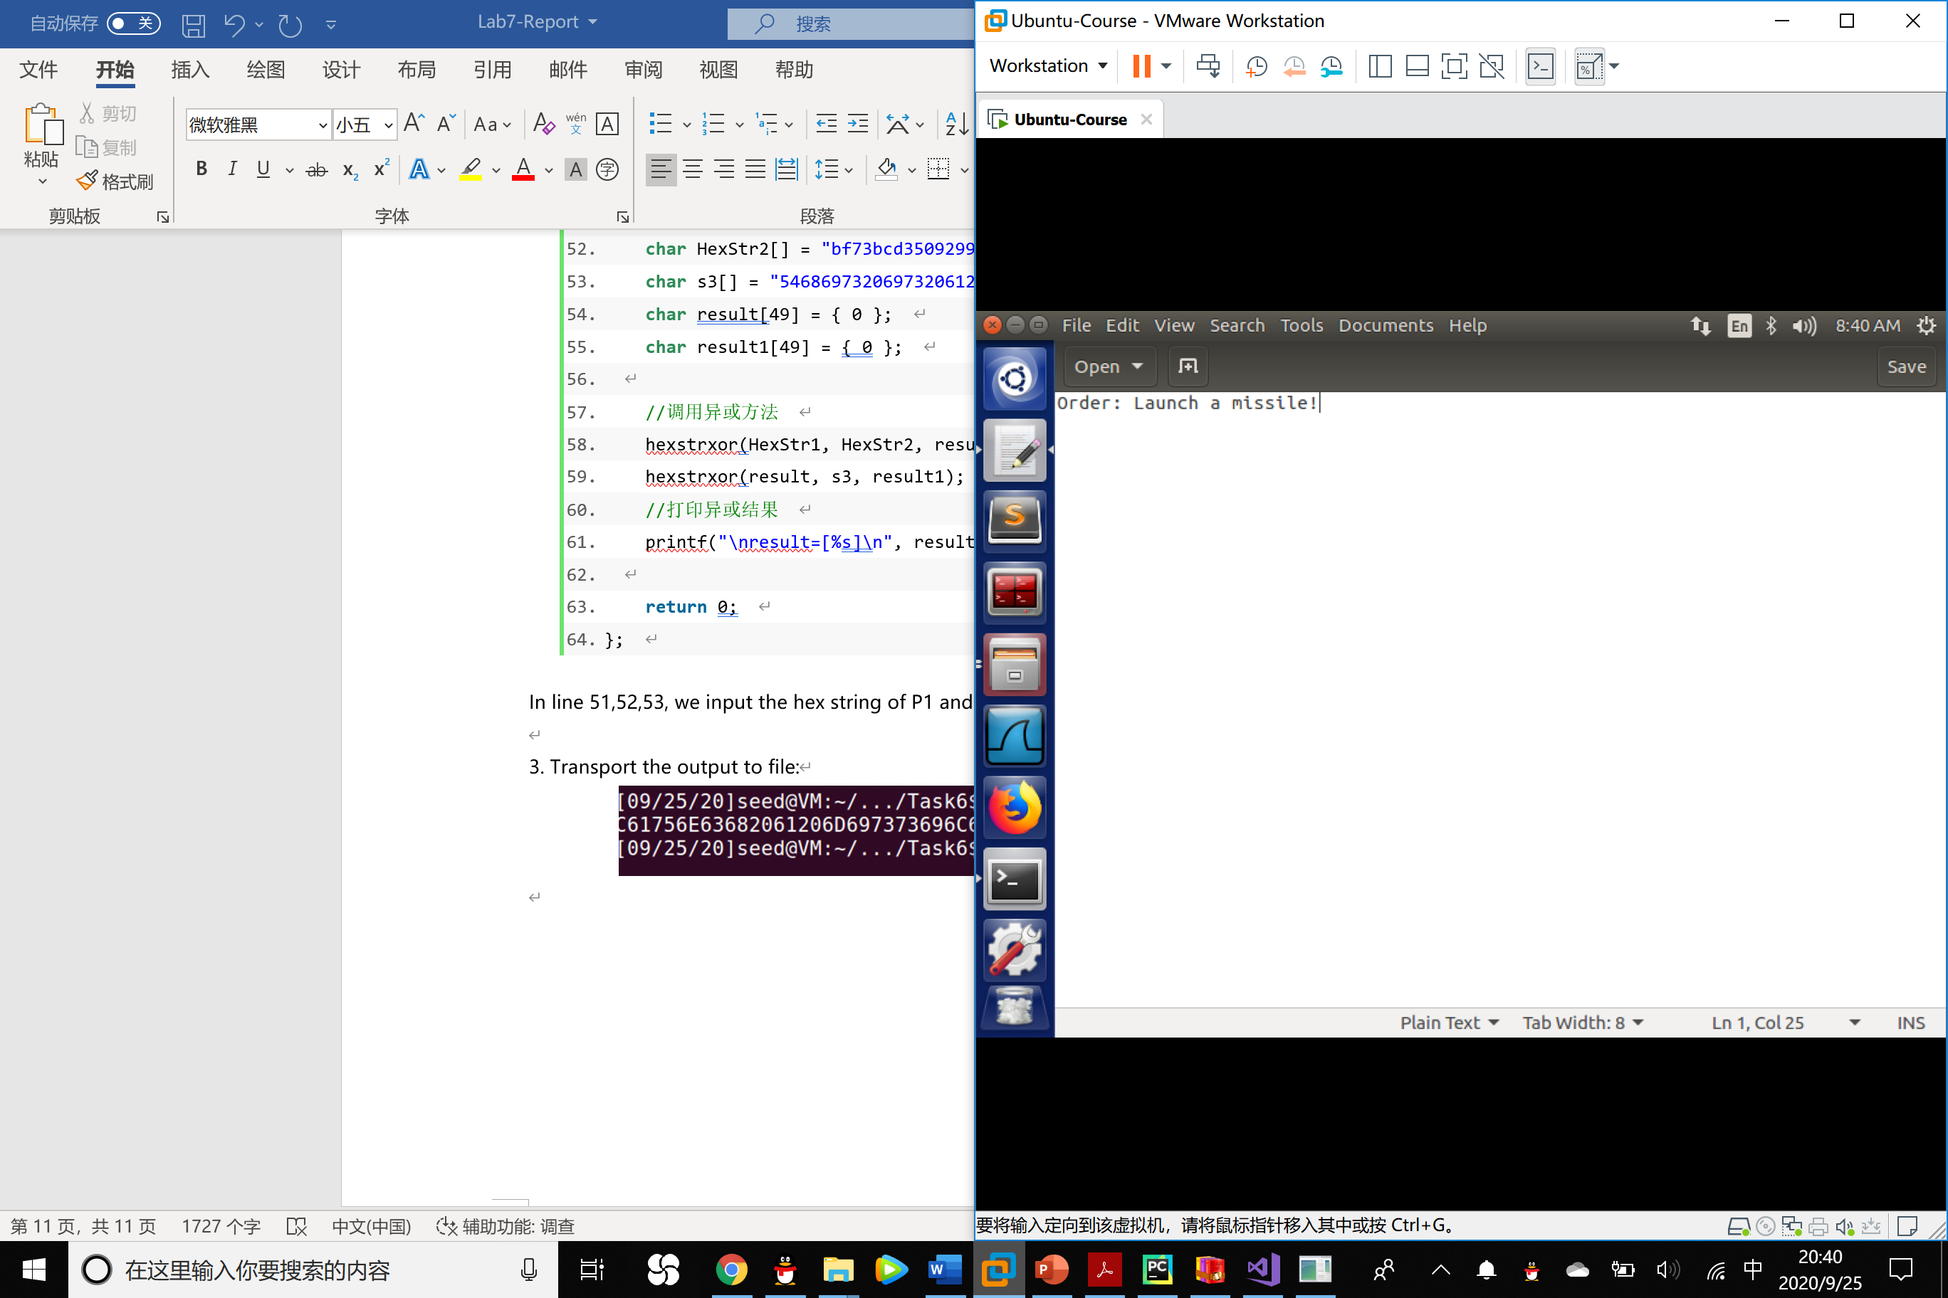

P2 answer: **Order: Launch a missile!**

Question：If we replace OFB in this experiment with CFB (Cipher Feedback), how much of P2 can be revealed? You only need to answer the question; there is no need to demonstrate that.

Answer: The number of information we can reveal is r bits, r represents for the length of LFSR.

3. From the previous tasks, we now know that IVs cannot repeat. Another important requirement on IV is that IVs need to be unpredictable for many schemes, i.e., IVs need to be randomly generated. In this task, we will see what is going to happen if IVs are predictable.

Assume that Bob just sent out an encrypted message, and Eve knows that its content is either Yes or No; Eve can see the ciphertext and the IV used to encrypt the message, but since the encryption algorithm AES is quite strong, Eve has no idea what the actual content is. However, since Bob uses predictable IVs, Eve knows exactly what IV Bob is going to use next. The following summarizes what Bob and Eve know:

Encryption method: 128-bit AES with CBC mode.

Key (in hex): 00112233445566778899aabbccddeeff (known only to Bob)

Ciphertext (C1): bef65565572ccee2a9f9553154ed9498 (known to both)

IV used on P1 (known to both)

(in ascii): 1234567890123456

(in hex) : 31323334353637383930313233343536

Next IV (known to both)

(in ascii): 1234567890123457

(in hex) : 31323334353637383930313233343537

A good cipher should not only tolerate the known-plaintext attack described previously, it should also tolerate the chosen-plaintext attack, which is an attack model for cryptanalysis where the attacker can obtain the ciphertext for an arbitrary plaintext. Since AES is a strong cipher that can tolerate the chosen-plaintext attack, Bob does not mind encrypting any plaintext given by Eve; he does use a different IV for each plaintext, but unfortunately, the IVs he generates are not random, and they can always be predictable.

Your job is to construct a message P2 and ask Bob to encrypt it and give you the ciphertext. Your objective is to use this opportunity to figure out whether the actual content of P1 is Yes or No. You can read this Wikipedia page for ideas: https://en.wikipedia.org/wiki/Initialization_

vector.

Analysis:

In CBC mode of AES encryption, we have:

C1=E(K,P1 xor IV1)

C2=E(K,P2 xor IV2)

We know that P1 should be either yes or no. So we want to make a P2, let Bob encrypt that, and check whether C1 is equal to C2.

To make C1 = C2, **P2 = P1 xor IV1 xor IV2**

Task 7: Programming using the Crypto Library

In this task, you are given a plaintext and a ciphertext, and your job is to find the key that is used for the encryption. You do know the following facts:

• The aes-128-cbc cipher is used for the encryption.

• The key used to encrypt this plaintext is an English word shorter than 16 characters; the word can be found from a typical English dictionary. Since the word has less than 16 characters (i.e. 128 bits), pound signs (#: hexadecimal value is 0x23) are appended to the end of the word to form a key of 128 bits.

Your goal is to write a program to find out the encryption key. You can download a English word list from the Internet. We have also linked one on the web page of this lab. The plaintext, ciphertext, and IV are listed in the following:

Plaintext (total 21 characters): This is a top secret.

Ciphertext (in hex format): 764aa26b55a4da654df6b19e4bce00f4

ed05e09346fb0e762583cb7da2ac93a2

IV (in hex format): aabbccddeeff00998877665544332211